Underpinning Policy
Provision of Look-up Tables for DfT Concessionary Travel Reimbursement Calculator
Report for Department for Transport (DfT)
MVA Consultancy and Minnerva Ltd
May 2012



Document Control
Project Title: | Provision of Look-up Tables for DfT Concessionary Travel Reimbursement Calculator
MVA Project Number: | C3A44000
Document Type: | Final Report
Directory & File Name: | /tmp/in/input.doc

Document Approval
Primary Author: | Andrew Last
Other Author(s): | Jon Crockett
Reviewer(s): | Andrew Last and Jon Crockett
Formatted by: | Nicola Milne

Distribution
Issue | Date | Distribution | Comments
1 | 06/01/2012 | Department for Transport | Draft report for discussion
2 | 22/02/2012 | Department for Transport | Final report for comment
3 | 27/04/2012 | Department for Transport | Final report
4 | 18/05/2012 | Department for Transport | Revised Final report

Contents
1 Introduction 1.1
1.1 Context 1.1
1.2 Structure of the Report 1.2
2 The NoWcard Dataset 2.1
2.1 The NoWcard Consortium and data included in the new NoWcard dataset 2.1
2.2 The NoWcard data 2.3
2.3 Concessionary Travel outside the ‘Area’ of Residence 2.5
2.4 Data Confidentiality 2.6
3 Data Checking and Cleaning 3.1
3.1 Introduction 3.1
3.2 Validation of Cardholders 3.2
3.3 Hotlisting 3.3
3.4 Manual Transactions 3.4
4 Choice of Area Type Classification 4.1
4.1 Introduction 4.1
4.2 Selection Criteria 4.1
4.3 ONS and Defra Urban / Rural Classification 4.2
4.4 DfT National Travel Survey (NTS) Classification 4.4
4.5 Recommendation 4.5
5 Passholder and Journey Characteristics 5.1
5.1 Overview 5.1
5.2 Variations in Concessionary Travel Behaviour 5.2
5.3 Frequency Distribution of Journeys 5.5
5.4 Other variations in journey making characteristics 5.10
6 Derivation of Look up Tables 6.1
6.1 Overall Process 6.1
6.2 Data selection issues 6.2
6.3 Derivation of look-up tables 6.4
6.4 Consolidation of Look-up Tables 6.7
6.5 Price Ratio Limits 6.10
6.6 Applying the Look-up Tables 6.10
7 Indicative Results from New Look up Tables 7.1
7.1 Testing the implications of new Look-up Tables 7.1
7.2 Overall Impact of the New NoWcard data on discount factors 7.1
7.3 Choice of Weighted or Un-weighted look-up tables 7.3
7.4 Impact of Area Type 7.3
8 Conclusions 8.1
8.1 Conclusions 8.1

Tables
Table 2.1 Summary of Population Estimates and NoWcard Customers within Sampled TCAs 2.4
Table 3.1 High Level Data Integrity Checks on NoWcard Journeys Records 01/09/2009 to 31/08/2010 3.1
Table 3.2 Verification of the Journeys Database against the CMS Database 3.3
Table 4.1 Count of Cardholders in Selected 10 NoWcard Districts by ONS / Defra Area Classification 4.3
Table 4.2 Count of Cardholders in Selected 10 NoWcard Districts by NTS Area Classification 4.5
Table 5.1 Passholders and Journeys by District 5.3
Table 5.2 Journeys per week by Defra/ONS Area Type 5.4
Table 5.3 Journeys per week by NTS Area Type 5.5
Table 5.4 Passholder Journey Frequencies 5.7
Table 5.5 Comparisons of Passholder Journey Frequencies 5.9
Table 5.6 Concessionary Pass Usage by Gender and Disability 5.10
Table 6.1 Example of Spreadsheet Calculation 6.5

Figures
Figure 2.1: NoWcard Travel Concession Authorities 2.2
Figure 3.1: Trend in Weighted and Unweighted Lancashire Concessionary Travel Demand 3.5
Figure 3.2: Trend in Weighted and Unweighted Cumbria Concessionary Travel Demand 3.6
Figure 4.1: ONS Classification applied to the 10 Selected NoWcard TCAs 4.7
Figure 5.1: Total Journeys per Annum by Postcode 5.2
Figure 5.2: Distribution of journey frequency by passholders making at least one journey 5.6
Figure 5.3: Cumulative passholder numbers plotted against cumulative journeys 5.6
Figure 5.4: Distribution of Average Journeys per Week by Age Band 5.10
Figure 6.1: Example of results from analysis of passholder data (fragment) 6.8
Figure 6.2: Example of output Look-up Table (fragment) 6.9
Figure 6.3: User Selection of Area Types 6.10
Figure 7.1: Discount Factors by source of Look-up Table 7.2
Figure 7.2: Discount Factors by Defra/ONS Area Type 7.4
Figure 7.3: Discount Factors by NTS Area Type 7.5

Summary
The work described in this Report was undertaken by MVA Consultancy and Minnerva Ltd under contract to the Department for Transport (DfT). The objective was to construct look-up tables which summarise the frequency with which concessionary passholders make bus journeys.
Look-up tables are a key element of the methodology that the DfT recommends to Travel Concession Authorities (TCAs) in England for the calculation of the reimbursement that should be paid to bus operators for carrying concessionary passengers, in particular older and disabled persons entitled to the English National free concession. The current methodology, and the spreadsheet calculator which DfT recommends that TCAs use, draws on a look-up table initially developed during a major study of concessionary travel reimbursement published in late 2010. The purpose of the work reported here was to develop replacement look-up tables that would be more robust by virtue of being drawn from a longer period of data, and from a wider representation of different area types.
Both the initial look-up tables and the new tables are based on data from the NoWcard consortium of local authorities and bus operators, which manages smartcard ticketing arrangements in Lancashire and Cumbria. Data from this source is valuable because of the completeness with which smartcard data on ticket transactions is available, and also because of the relative ease with which appropriate data can be extracted in a suitable form for analysis. Although the frequency with which these conditions are met elsewhere is increasing, the NoWcard data remains a key source of this information.
Data has been extracted for over 12 million concessionary journeys made in the NoWcard area between September 2009 and August 2010, by nearly 200,000 individual passholders. The passholders are all resident of one of four Districts in Lancashire (Chorley, Lancaster, South Ribble or Wyre) or the six districts of Cumbria. The Cumbria districts were not in the initial look-up table, and their inclusion greatly increases the diversity of area types covered by the look-up tables, especially with regard to rural areas.
Analysis has identified the number of journeys made on each day of the year by each passholder, from which it is possible to infer on how many occasions a daily or weekly ticket would have been cheaper to use for these journeys rather than equivalent cash single fares. With various other manipulations, the DfT methodology uses this information to estimate the relative use of cash, daily or weekly tickets in the counter-factual situation of there being no concession, and hence the discount factor that should be applied to the cash fare to estimate the average fare that would have been paid by passholders in the absence of the concession.
A key element of the work has been the creation of distinct look-up tables for residents of different types of area. This has demonstrated the importance of recognising that journey frequencies and hence the propensity to purchase discount tickets varies significantly between area types. However, the results also confirm that, as would be expected, the available NoWcard data will not be fully representative of all area types (in particular, larger and denser urban areas) and DfT may wish to consider whether further work is required to identify data from these other areas that can be used to enhance the generality of the discount factor method.

Introduction

Context

This Report describes the data and analysis that have contributed to the production of new look-up tables that could be used as part of the DfT Concessionary Travel Calculator.

The Calculator is a spreadsheet tool developed by DfT to aid Travel Concession Authorities in their calculation of the reimbursement due to bus operators. Part of the calculation involves the estimation of the average fare per journey that concessionary passholders would pay in the absence of the concessionary scheme. The recommended discounted fare method involves the simulation of the extent to which passholders would purchase discounted day and week tickets, if these are offered by the bus operator alongside cash fares. The method translates the propensity to purchase these non-cash fares into a discount factor that can be applied to the average cash fare.

The simulation uses as a reference point an observed distribution of concessionary passenger journey frequencies, in other words the proportions of passholders making one, two, three (and so on) journeys per day and week. The distributions are summarised into a look-up table, which in the current version of the calculator is based on analysis of smartcard data for five weeks in early 2009, from four Districts in Lancashire which are part of the NoWcard smartcard consortium.

The current look-up table was derived during the course of the research programme on concessionary travel reimbursement led by the Institute for Transport Studies (ITS) at Leeds University. The ITS work provided the basis of much of DfT’s current Guidance to Travel Concession Authorities on reimbursement. At the time the Guidance was under development, the five weeks of NoWcard data was the only suitable data that was readily accessible.

The project which is reported here has the aim of expanding the smartcard database so as to improve the representativeness of the look-up tables, in two respects:
- the geographical scope of the data has been expanded from just four districts in Lancashire to these, plus the six Districts in Cumbria which are also part of the NoWcard consortium. Critically, this increases the representativeness of the look-up tables with regard to rural areas, where it could be expected that journey frequencies (and hence propensity to use discount tickets) would be lower; and
- the time period of included concessionary journeys has been expanded to a full year, from September 2009 to August 2010 inclusive, providing more assurance of freedom from seasonal bias. The year selected also includes the same five period as the initial analysis, but one year later, allowing comparison to be made between the look-up tables (and resulting discount factors) associated with similar five week periods one year apart.

The project is seen as part of a process of incrementally improving the representativeness of the look-up tables, and was commissioned to exploit the relatively low-cost accessibility of additional NoWcard data. The scope of work has been tailored to fit within the available budget. While delivering look-up tables that are fit for purpose, there has been very limited opportunity to fully examine the dataset for insights into concessionary passholder behaviour that are not directly relevant to the core objective of the work. Much could be gained from further analysis of the data.

In due course more smartcard data is likely to become available from a wider range of areas, giving the potential for construction of additional look up tables. If such look-up tables were integrated with the Concessionary Travel Calculator, this would further increase the generality of the average fare estimation method.

The assistance of the NoWcard Consortium in facilitating access to its data is gratefully acknowledged. The co-operation of the NoWcard consortium and its constituent Travel Concession Authorities and bus operators has been instrumental in enabling the DfT discounted fare method to be put into practice, and we are very grateful for the assistance of relevant staff, particularly in dealing with the very substantial volumes of data involved in the project.

Structure of the Report

This Report is structured as follows:
- Chapter 2 describes the NoWcard dataset itself, the origins of the data, its contents, and the criteria for its selection;
- Chapter 3 describes the data checking and cleaning processes undertaken to ensure the robustness of the data used for analysis;
- Chapter 4 discusses the issue of area type selection, which is a key aspect of the process through which the implications of the NoWcard data can be generalised to other parts of England;
- Chapter 5 sets out a summary analysis of passholder and concessionary journey characteristics, and contrasts these with the earlier NoWcard dataset and other comparative data;
- Chapter 6 describes how the new look-up tables were derived;
- Chapter 7 sets out some indicative results of the application of the new look-up tables to indicative discount factor calculations; and
- Chapter 8 presents overall conclusions.

The look-up tables themselves, which are the key deliverable from the project, have been constructed so that they can be readily incorporated into the DfT Calculator or equivalent tools. They are too voluminous to be provided in printed form, but will be supplied to DfT in a spreadsheet format for further review, analysis and application. Chapter 6 documents some of the features of the spreadsheet, and also describes a method that has been developed for combining look-up tables from different area types.

The NoWcard Dataset

The NoWcard Consortium and data included in the new NoWcard dataset

The NoWcard consortium was jointly established by Lancashire and Cumbria County Councils, and Blackburn with Darwen Borough and Blackpool Councils, to manage the local concessionary travel scheme. In its original form stemming from the Transport Act 2000 and earlier localised schemes, it entitled older people, defined as those of pensionable age, and disabled people, to discounted travel on local bus services during off-peak periods, with a minimum discount of half the equivalent adult fare.

From April 2006, the Scheme provided the mechanism for local delivery of the statutory entitlement for free travel on local services created by the Travel Concessions (Extension of Entitlement) (England) Order 2005 (the “English National Concessionary Travel Scheme” or ENCTS). The Concessionary Bus Travel Act 2007 extended this further to permit non-local travel on ENCTS passes and cards throughout England from April 2008. Recent changes have seen the entitlement age for older people increase, and linked to changes in the female State Pension Age (SPA), which is planned to increase to 66 by 2020.

The consortium covers 20 District Councils, 14 in Lancashire and 6 in Cumbria. From 2005, the consortium began the introduction of ITSO smartcards, providing a leading edge electronic system for managing ENCTS passes and also for monitoring concessionary pass usage. The successful operation of the Scheme requires close working with bus operators and other agencies in issuing and managing passes, and equipping buses and operators’ back offices with the equipment to read smartcards. There are 16 principal bus operators within the NoWcard area, plus ‘groups’ of small operators in Lancashire and Cumbria whose day-to-day interaction with the ENCTS and concessionary fare reimbursement is given additional support by the NoWcard consortium. All operators in the NoWcard area are smart-equipped, ensuring any gaps or errors in the data are a result of system failures or errors, rather than inconsistencies in data collection and reporting across operators.

In addition to the statutory entitlement for free off-peak travel, NoWcard disabled passholders from Lancashire, Blackburn with Darwen Borough, and Blackpool are entitled to travel before 9:30 am on weekdays at a 50p flat fare for local bus journeys starting or ending within their area. No other peak time discounts are provided by area or passholder type. NoWcard is valid for use in English TCAs outside the consortium’s area in line with the Concessionary Bus Travel Act 2007.

The four Lancashire TCAs used in the 2009 ITS study (Chorley, Lancaster, South Ribble, and Wyre) were selected because they covered areas in which operators had been smart ‘enabled’ for some time, providing stability and robust operator electronic systems. The initial dataset covered a five week period in February and March 2009. The selection of these districts also minimised ‘boundary’ problems, in contrast to other districts in which non-NoWcard operators provide a large proportion of scheduled bus-kms.

The data collected for the new work was from a period starting six months later, providing more time for new smart systems to bed-down and initial teething troubles to be overcome. This allowed the geographical scope to be extended to include the six Cumbria districts – Allerdale, Barrow-in-Furness, Carlisle, Copeland, Eden and South Lakeland. Here, the overwhelming majority of services were provided by a single operating group with known stability in their electronic systems, thus minimising boundary problems and reducing the potential for data issues. The inclusion of Cumbria significantly extends the types of area and geographies covered by the data set.

Figure 2.1 shows the 10 districts included in the “new” NoWcard dataset.
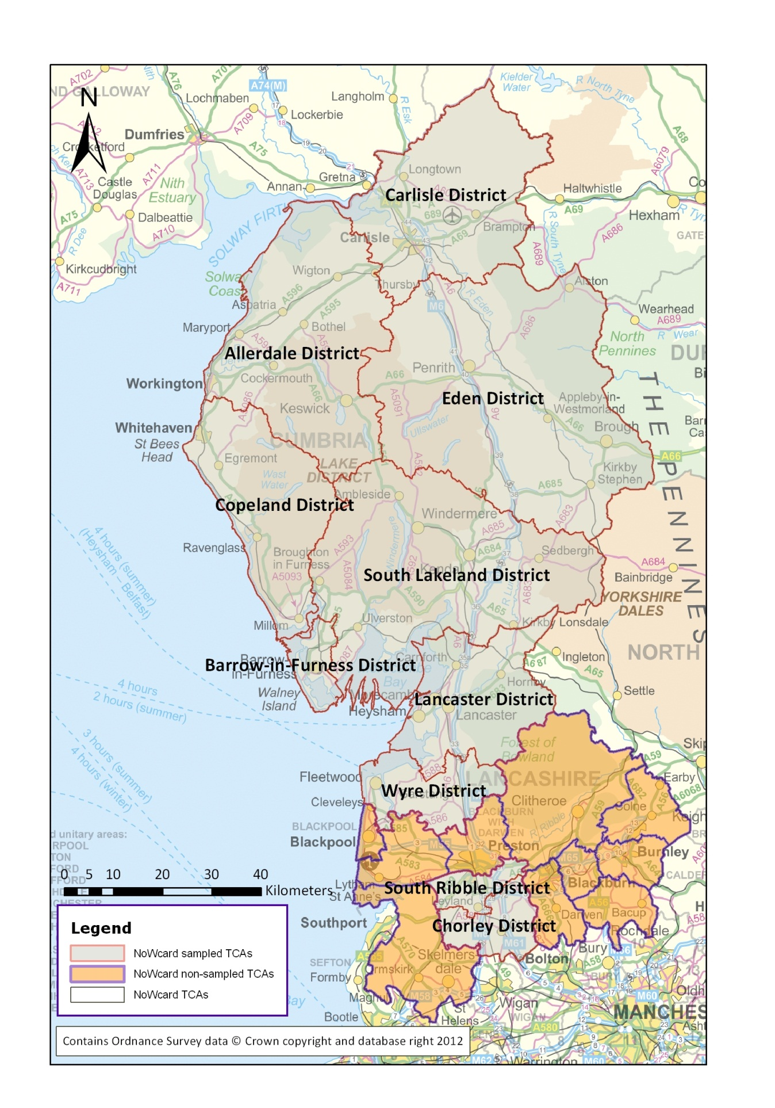
Figure 2.1: NoWcard Travel Concession Authorities

The NoWcard data

To preserve anonymity, information on passholders and their travel is held in two separate databases. These are referred to here as the Card Management System (CMS) and ‘Journeys’ databases, respectively. The databases were designed to provide the most robust means of monitoring pass usage by each individual cardholder. This ensures that old cards or those which have been fraudulently used can be disabled, and gives the capacity to link each cardholder back to a set of personal characteristics.

The CMS database contains information on the:
- unique customer reference number – which stays with the customer if they have multiple cards issued to them;
- customer’s home postcode (full detail), providing the capacity to link to a host of additional datasets pertaining to the area;
- customer’s date of birth;
- customer’s gender;
- customer’s disability (if any);
- unique card reference number;
- date of issue for each card;
- status of each card, grouped into either ‘cold’ (eligible for use – each customer can only have one ‘cold’ card) or ‘hot’ (no longer valid for use); and
- resident TCA.

As of 31st August 2010, there were 192,901 cardholders within the ten TCAs included in the dataset, of which up to about 8% may have been issued on grounds of disability. Because there are no definitive statistics on the population likely to be eligible for the concession on grounds of disability, it is not possible to identify the overall take up rate of the concession. However, to provide an indication of take up, Table 2.1 compares passholder numbers with Office for National Statistics (ONS) 2008 Annual Population Estimates for females aged 60 and over and males aged 65 and over. Note that these will be approximate because:
- the population data excludes eligible disabled persons;
- it does not include males aged between 60 and 65, most of whom will be eligible for the concession on grounds of age, and there will also have been a slight increase in the older population from the 2008 ONS estimate. Moreover, there is no definitive population estimate of those who would be deemed disabled for concessionary travel purposes, and therefore these cannot be included in any estimate of pass take-up.
- The number of passholders is based on records of the cards that have been issued; each card is valid for five years from the date of issue. Cards may therefore remain recorded as “live” even though the passholders to which they have been issued have deceased or moved away. The requirement to renew after five years is the only reliable mechanism available to confirm that a pass is validly held.

The difficulty of accurately monitoring passholder numbers is a common problem to all Travel Concession Authorities, and caution is needed in discussing estimated take-up rates in the NoWcard area, or anywhere else. In Table 2.1 the effect of the above caveats is most clearly demonstrated in the data for South Ribble District, where, due to one or more of the above issues, the estimated uptake exceeds 100%.
Table 2.1: Summary of Population Estimates and NoWcard Customers within Sampled TCAs
Travel Concession Authority | County | 2008 ONS Annual Population Estimate: aged 65 and over (males), and 60 and over (females) | NoWcard customers | Estimated Percentage Uptake¹
Chorley | Lancashire | 20,100 | 19,289 | 96%
Lancaster | Lancashire | 29,100 | 28,897 | 99%
South Ribble | Lancashire | 21,900 | 22,167 | 101%
Wyre | Lancashire | 30,200 | 28,333 | 94%
Allerdale | Cumbria | 22,200 | 18,539 | 84%
Barrow-in-Furness | Cumbria | 15,200 | 14,256 | 94%
Carlisle | Cumbria | 22,600 | 19,738 | 87%
Copeland | Cumbria | 15,000 | 9,303 | 62%
Eden | Cumbria | 12,700 | 8,777 | 69%
South Lakeland | Cumbria | 28,100 | 23,602 | 84%
Total |  | 217,100 | 192,901 | 89%
Notes: (1) Subject to the caveats surrounding comparisons between the two datasets.

These estimated take-up rates are somewhat higher than the concessionary travel scheme take-up observed in the DfT’s National Travel Survey (NTS), which is able to accurately match both pass eligibility and actual status of passholding. In 2009 NTS reported take-up rates which varied between 63% in rural areas to 79% in large urban areas in 2009. While the absolute accuracy of the take-up percentage is uncertain, the differences between the Districts should be relatively reliable. In this respect, it is worth noting, with reference to Figure 1.1, that the TCAs with the lowest take-up, Copeland and Eden, are the most rural of the TCAs covered in this new analysis. Each contains one significant settlement, Whitehaven (population approximately 25,000) in Copeland and Penrith (population approximately 15,000) in Eden. The principal factors behind lower take-up are likely to be higher levels of car ownership and lower levels of bus provision, and the interactions between these two factors.

The cards can be used on the services of all operators in the NoWcard area; consequently all concessionary journeys made by NoWcard passholders within the area will be electronically recorded, provided the equipment is able to process the transaction. The journey data is stored in the ‘Journeys’ database.

This contains a record for each electronic transaction using a NoWcard smartcard within the area, with each record holding the following information:
- unique journey ID;
- unique customer reference number;
- unique card reference number;
- date of journey;
- time of journey;
- operator;
- service number;
- boarding and (stated) alighting stage; and
- fare foregone (the equivalent adult cash fare).

For the period 01/09/2009 to 31/08/2010, there were 11,825,602 journeys recorded as smart transactions in the ten selected TCAs, an average of 61.3 journeys per annum per customer in the CMS database, including passholders making no use of their pass. These journeys were made by 128,031 individual cardholders, an average of 92.4 journeys per annum per ‘active’ customer i.e. for each passholder making at least one journey in the year.

Concessionary Travel outside the ‘Area’ of Residence

The data recorded in the NoWcard ‘journeys’ database relates solely to local travel by NoWcard residents on operators serving the NoWcard area. It therefore excludes:
- use of the smartcard by NoWcard residents on services by operators not in the NoWcard area. For example, travel whilst on holiday [outside of the NoWcard area]; and
- use of non-NoWcard ENCTS passes in the NoWcard area by non-NoWcard residents.

The absolute volume of concessionary journeys made in the NoWcard area, or by NoWcard passholders outside the NoWcard area will therefore be underestimated. However, nothing is currently known about how the frequency distributions of these “missing” journeys compares with those fully captured in the data, and the factors influencing discount ticket purchasing decisions are likely to be even more complex for these journeys. Since it seems likely that overall, the journey numbers involved are relatively small, it is felt that the non-capture of these journeys is unlikely to affect the validity of discount rates inferred from the resulting look-up tables. Once all TCAs in England are smart enabled and the electronic systems stable on a nationwide basis, such travel should be capable of being monitored, and it may be feasible to develop appropriate methodologies for including this element of demand in the discount factor calculation.

Data Confidentiality

As the data can be used to examine travel demand and behaviour at a very detailed level, and is therefore highly commercially sensitive, it is vital for the integrity of the NoWcard scheme and the trusted relationships between the consortium and operators that the raw data for each individual cardholder is not made available to third parties beyond those already involved in the day-to-day management of the scheme. As such, the aggregate analysis documented within this report represents the finest level of spatial detail at which concessionary travel behaviour can be analysed without breaching operator or passholder confidentiality.

Data Checking and Cleaning

Introduction

Prior to the processing necessary to create the lookup tables, the NoWcard ‘Journeys’ dataset was subject to extensive cleaning and checking procedures. These included:
- identifying any missing data, particularly customer references or card numbers;
- ensuring that all journeys were made between 01/09/2009 and 31/08/2010;
- validating non-disabled cardholders’ date of birth for older entitlement, and the ages of older cardholders;
- checking for duplicate journeys;
- missing disability classifications;
- null values;
- calculating the maximum number of journeys made and number of cards held by an individual customer in the 12 months; and
- verifying that all journeys were made on a NoWcard operator.

Table 3.1 provides a summary of these high level data integrity checks for the ten selected TCAs.
Table 3.2: High Level Data Integrity Checks on NoWcard Journeys Records 01/09/2009 to 31/08/2010
Check | Summary | Action
Missing card numbers | Zero | N/A
Missing customer reference numbers | Zero | N/A
Total journeys and journeys made outside of sampled period | 11,825,602, clean and smart recorded (all between 01/09/2009 and 31/08/2010 inclusive) | N/A
Date of Birth | - 7 cardholders aged 58-55, 32 cards issued with cardholder < 55  - 2 cardholders with erroneous dates of birth (01/01/2000 and 01/04/2000) | - Assumed missing disability  - Journeys included, but excluded from analysis of behaviour by age band
Duplicate journeys | - Zero | - N/A
Disability classification | 4% of all disabled journey records having a missing fine-grain disability classification | No analysis by fine-grain band, so no effect on analysis
Null values | 120 journeys with missing postcode (one customer) | TCA recorded, but customer had to be excluded from area type analysis
Maximum number of journeys per annum | 2,252 | Plausible extreme outlier, at approx’ 6 to 7 journeys per day
Maximum numbers of cards held per annum per customer | 7 | Plausible, given propensity to lose or damage card
Journeys without NoWcard operator | Zero | N/A

Validation of Cardholders

In order to verify that the ‘Journeys’ database contained all demand within the ten TCAs, and valid customer references and ‘cold‘ card numbers, unique customer references were mapped back to the CMS. The CMS contains a log of all smartcards issued from November 2007 onwards, as the NoWcard consortium prepared for the introduction of the national concessionary travel scheme. To account for the date the first smartcard concessionary travel pass was issued, a series of queries were undertaken on the data to identify the first card issued amongst cardholders who had been issued two or more NoWcards since November 2007. Table 3.2 summarises the results of this high level integrity check. The analysis reveals a high level of validation between the two databases, demonstrating the robustness of the ‘Journeys’ database for underpinning the lookup tables. The small differences between the two absolute numbers are likely to be accounted for through:
- hotlisting (see below);
- data format issues; and
- mismatches in the dates of update.

An estimated 66% (127,706 or 128,031 / 192,901) of cardholders made journeys during the year, with the caveat, as noted above, that some of the 192,901 NoWcard customers are likely to have moved outside the area or deceased since their card was issued.
Table 3.3: Verification of the Journeys Database against the CMS Database
Travel Concession Authority | County | CMS Cardholders – journey-makers | Journeys database unique customers | Percentage of CMS Cardholders identified in ‘Journeys’ database
Chorley | Lancashire | 12,296 | 12,350 | 99.6%
Lancaster | Lancashire | 19,430 | 19,143 | 101.5%
South Ribble | Lancashire | 15,153 | 15,228 | 99.5%
Wyre | Lancashire | 18,123 | 18,213 | 99.5%
Allerdale | Cumbria | 12,127 | 12,192 | 99.5%
Barrow-in-Furness | Cumbria | 10,619 | 10,558 | 100.6%
Carlisle | Cumbria | 15,514 | 15,773 | 98.4%
Copeland | Cumbria | 6,234 | 6,410 | 97.3%
Eden | Cumbria | 4,839 | 4,916 | 98.4%
South Lakeland | Cumbria | 13,371 | 13,248 | 100.9%
Total |  | 127,706 | 128,031 | 99.7%

Hotlisting

NoWcards can be hotlisted for a variety of reasons, including loss, damage, misplacement, theft, electronic faults, or alleged misuse (eg attempted use by another family member or friend). In reality, the vast majority are a result of loss, damage, or a fault. The hotlisting record for each card, and thereby journey, relates to the current status of the card. It is therefore very feasible for journeys to be made on a ‘cold’ card which subsequently becomes ‘hot’ when it is, for example, lost, placing valid journeys at risk of exclusion. The CMS database tracks the date of hotlisting, but suffers from a significant degree of incompleteness. Instead of a blanket exclusion of journeys made on ‘hot’ cards, a match back to the CMS database allowed customers whose last issued card was ‘hot’ to be flagged. This resulted in no matches to customers currently making journeys.

Based on this analysis and internal knowledge of NoWcard management and usage, it is therefore deemed very unlikely that fraudulent use will have a significant effect on analysis of travel behaviour amongst concessionary pass holders.

Manual Transactions

A proportion of concessionary travel demand is not recorded as a smart transaction because of failures in electronic systems (either ticket machines or the smartcards themselves), or, alternatively, drivers entering valid smartcards with button presses for a variety of reasons. Collectively termed ‘manual’ transactions, these are recorded separately from smart transactions by operators, but are recorded at varying levels of temporal detail. Typically, where there is a one-off system failure or issue, an operator will log the manual transactions for the affected period(s) separately. If system failures are relatively constant throughout the year, operators would typically report a single manual transaction number.

Failure to account for gaps in the data, by operator and period, could bias the content of look-up tables relative to the (unobservable) actual pattern of journey making. However, the scale of the bias, and the extent to which correction could lead to a bias in the opposite direction, depends upon the exact pattern of recording failure and how this relates to the underlying concessionary travel patterns. Note that this issue is quite distinct from the need to correct for under-recording of journeys when the data is being used to measure the absolute volume of concessionary journeys (e.g. for the purposes of measuring average journey rates).

The ten TCAs were selected to minimise the uncertainties created by these problems, based on internal knowledge of where electronic system failures were at a minimum and/or relatively constant throughout the year. In particular, the authors’ in-depth knowledge of system reliability by operator guided the selection of sampled districts. Recorded smart transactions provided by the operators were verified against the demand recorded in the ‘Journeys’ database. Monthly trends from the latter were then plotted by operator to identify outliers which could not be explained by aggregate seasonal trends in concessionary bus demand. Expansion factors for each period were calculated based on the manual transaction returns provided by each individual operator and the smart transactions in the ‘Journeys’ database to create ‘weighted’ journeys. Factors were created for each period and operator, and matched to the NoWcard ‘Journeys’ database on the date of the journey, with journeys recorded separately for each day in the sampled year, and the recorded operator. For example an expansion factor of 1.02 for Operator X in Period Y, would, for a customer making 2 recorded journeys on a given day in that period, result in a final value of 2.04 (2 * 1.02).

As an example of how an expansion factor is derived:
- Operator X reports its electronic smart transaction records for a given Period Y, e.g. 100,000 records, which can be verified against the individual journey records passed back to that database;
- at the same time, and particularly when the period(s) in question have had a significant issue with regard to the reliability of smart transactions, then ‘manual transactions are also reported to the NoWcard consortium to give the total number of journeys for reimbursement is being claimed. Consider, for example, that Operator X also records 2,000 manual transactions in Period Y, giving a total of 102,000 concessionary journeys over the period, and an expansion factor of 1.02 (102,000 / 100,000); and
- because each journeys record in the NoWcard database has a date, which can be mapped to an operator period, and the operator ID, then the expansion factor, or weight, can be appended to give each record. Unweighted and weighted journeys can then be summed accordingly across passholders and periods or months.

Figures 3.1 and 3.2 show the trends in weighted and unweighted journeys for all 14 Lancashire and 6 Cumbria TCAs respectively, which differ in their definition of periods. The longer Period 08, and shorter Period 09, around Easter 2010 in the Lancashire data must be recognised. The most significant issue is during Period 05 in Lancashire, where one operator, serving only the margins of the ten selected TCAs, had a major issue with its Electronic Ticket Machines (ETMs). As this one issue was likely to have a very small effect on the overall analysis, and to preserve the most accurate reflection of concessionary travel demand across a complete year, then the decision was made to include the period and operator within the analysis.
Figure 3.2: Trend in Weighted and Unweighted Lancashire Concessionary Travel Demand
Figure 3.3: Trend in Weighted and Unweighted Cumbria Concessionary Travel Demand

The overall order of magnitude of expansion across the ten sampled TCAs is small, at 2.9%, resulting in 12,167,415 ‘weighted’ journeys. Expansion factors by TCA vary from 1.6% to 6.4%, with the upper value served by a single operator with consistently higher transaction failures across all periods.

The choice of unweighted or weighted journey data as the basis for the construction of look-up tables has a significant impact on the discount factors subsequently calculated. Further investigation is needed of the incidence of transaction failures, and the correlations with the journey-making frequency of passholders, in order to assess whether the potential bias arising from ignoring failed transactions (i.e. using un-weighted data) is more, or less, than the potential bias introduced by using journey data after it has been multiplied by expansion factors. There is further discussion of this issue in Chapter 6.

Choice of Area Type Classification

Introduction

Both the take-up of concessionary passes and usage varies between the Districts within the NoWcard area. The earlier ITS work established that journey rates vary by type of area, as would be expected, and it therefore seemed likely that journey frequency distributions, and their implications for estimated discount factors in the DfT Reimbursement Calculator, would also vary by type of area. Part of the current work was therefore directed at constructing separate look-up tables for passholders resident in different area types. In principle this would therefore allow a Travel Concession Authority of a given area type, or more probably a combination of area types, to select the look-up tables used to derive discount factors so as to better match its geographical characteristics.

There are numerous ways in which area types could be categorised. In this instance, what was required was a classification that fulfilled two practical requirements:
- the ability to associate the residential postcode of individual passholders in the NoWcard data to the selected area type classification. This was required to construct look-up tables disaggregated by area type; and
- availability of population or similar demographic data on a national scale that could be assigned to the chosen classification, in such a way that a Travel Concession Authority could identify which area types were the best fit to its own characteristics.

Two potentially appropriate sources of area type classifications were identified:
- Office for National Statistics (ONS) urban / rural classification, which has been extended by Defra to give a more detailed representation in rural areas; and
- DfT National Travel Survey (NTS) typology.

Each of these classifications enables individual postcodes to be associated with a particular area type. The spatial level at which the classification is available determines the extent to which fine-grain variation in travel behaviour will be captured, as opposed to being blurred by the averaging process inevitable with coarser levels of spatial detail.

The same classifications of area types need to be used for both derivation of the look-up tables (from the NoWcard data) and their application (to TCAs throughout England). In applying look-up tables differentiated by area type, it is not necessary for individual TCAs to have access to area-type data at the same level of spatial detail as that used in this analysis. However, appropriate population statistics by TCA for weighting purposes would need to be available on a consistent basis. One approach would be for DfT to draw together relevant population data for TCAs, as a once-off exercise to facilitate TCA application of look-up tables by area type.

Selection Criteria

Key criteria for evaluating the appropriateness of the classifications to the calculator included:
- public availability of GIS layer(s) and/or lookup tables, which could be used to allocate postcode to an ‘area type’;
- sufficient sub-samples in each area type to provide a robust basis for quantifying variation in travel behaviour;
- spatial coverage and detail;
- categories, number of, and definition; and
- integration with other datasets and DfT business needs.

It should be noted that under current statutory arrangements, a TCA reimburses operators for concessionary journeys that start within its area, irrespective of the area of residence of the passholders making these journeys. If the Reimbursement Calculator is modified to give some choice of look-up tables, selection criteria can only be based on the area type appropriate to the TCA’s own residents. This will not necessarily correspond with the journey patterns for which operators will seek reimbursement, which will include those by non-resident passholders which happen to start in the TCA’s area.

ONS and Defra Urban / Rural Classification

Key facets of this dataset include:
- Data is available at four distinct levels, commencing from the most spatially fine-grain;
  - Output Area (OA) , having a total population of around 300 people (on average);
  - LSOA, having a total population of around 1,500 people (on average);
  - Middle Super Output Area (MSOA);
  - Wards;
- includes ‘sparsity’ - a measure of local area postcode density, which is not available at a local authority level;
- the six classifications are;
  - Urban >10K [population], sparse;
  - Town and Fringe, sparse;
  - Village, hamlet & isolated dwellings, sparse;
  - Urban >10K [population], less sparse;
  - Town and fringe, less sparse;
  - Village, hamlet & isolated dwellings, less sparse;
- for the more spatially detailed geographies, villages can be separated from hamlets & isolated dwellings, creating an eightfold classification;
- alternatively, area types can be aggregated to one of four by removing sparsity from the consideration;
- national coverage is provided;
- there is a spatially coarser, local authority level, classification, which comes with a number of caveats from Defra and the dataset creators regarding it use due to aggregation of small areas with significant variation in typology and concerns about the averaging processes employed at such a coarse level;
- enhanced detail, and sufficiently robust sub-sample sizes, for cardholders in rural areas; and
- lack of detail in larger urban areas (eg only one classification for all urban areas of >10K population).

The distribution of passholders of the 10 NoWcard districts between the ONS area types is summarised in Table 4.1. This shows that, overall, all 8 ONS area types at the most spatially detailed are represented by substantial numbers of passholders, giving some confidence that look-up tables constructed on this basis would be statistically robust.
Table 4.4: Count of Cardholders in Selected 10 NoWcard Districts by ONS / Defra Area Classification
Code | Area Classification | Cardholders in selected NoWcard Districts | Percentage
1 | Sparse – Urban >10K | 2,982 | 1.5%
2 | Sparse – Town and Fringe | 8,087 | 4.2%
3 | Sparse - Village | 6,916 | 3.6%
4 | Sparse – Hamlet and Isolated Dwellings | 4,244 | 2.2%
5 | Less sparse – Urban >10K | 117,578 | 61.0%
6 | Less sparse – Town and Fringe | 30,573 | 15.9%
7 | Less sparse - Village | 15,851 | 8.2%
8 | Less sparse – Hamlet and Isolated Dwellings | 6,430 | 3.3%
Total |  | 192,661¹ | 100%
Note: (1) The number of cardholders by area type is lower than Table 1 due to some postcodes not being successfully allocated to an area type.

DfT National Travel Survey (NTS) Classification

Key facets of this dataset include:
- areas are assigned to one of seven classes;
  - London boroughs;
  - metropolitan areas (equivalent to English PTEs, but excluding South Yorkshire);
  - large urban, self-contained urban areas over 250,000 population;
  - medium urban, self-contained urban areas with populations between 25,000 and 250,000;
  - small/medium urban, self-contained urban areas with populations between 10,000 and 25,000;
  - small urban, self-contained urban areas with populations between 3,000 and 10,000;
  - rural, all other areas including urban areas of under 3,000 population;
- NTS interviews therefore seem most likely to assign by local authority (district/borough), rather than any urban/rural split therein;
- the DfT will need to make a national gazetteer available or provide resident population statistics for each TCA for each area type;
- can be referenced to a variety of other personal travel data, collected on a systematic and robust basis by the DfT through the National Travel Survey (NTS) and other complementary programmes;
- lack of detail in rural areas; and
- enhanced detail, and robust sub-sample sizes, in urban areas of greater than 3K population, barring the 100 to 250K band.

Table 4.2 shows the distribution of passholders in the selected NoWcard districts between areas classified on the NTS basis.
Table 4.5: Count of Cardholders in Selected 10 NoWcard Districts by NTS Area Classification
Code | Area Classification | Cardholders in selected 10 NoWcard Districts | Percentage
10 | Non-Met urban over 250K | 48,514 | 25.2%
11 | Non-Met urban 100K to 250K | 33 | 0.0%
12 | Non-Met urban 50K to 100K | 35,158 | 18.2%
13 | Non-Met urban 25K to 50K | 20,854 | 10.8%
14 | Non-Met urban 10K to 25K | 14,852 | 7.7%
15 | Non-Met urban 3K to 10K | 28,137 | 14.6%
16 | Rural | 45,113 | 23.4%
Total |  | 192,661¹ | 100%
Note: (1) The number of cardholders by area type is lower than Table 1 due to some postcodes not being successfully allocated to an area type.

Of the total NTS area types, some of course are not represented at all (e.g. London Boroughs and Metropolitan Areas), and only 33 passholders are assigned to the “Non-Met urban 100K to 250K population category. At first glance, there is a reasonable distribution of passholders between the other 6 classifications. However, the NoWcard areas allocated to “Non-Met urban over 250K”, which seem to be Fleetwood (adjacent to Blackpool) and Leyland (adjacent to Preston) may not be properly representative of larger, denser urban areas elsewhere. This might explain the lower journey rates associated with this area type which are discussed later.

Recommendation

The preferred option for the immediate future is the ONS/Defra classification which is available at both OA and LSOA levels. This is because of its finer level of detail in rural areas, and its public availability and widespread use. However, the NTS-based classification offers the equivalent benefit of greater detail in urban areas, although we are sceptical of the representativeness of the densest urban areas reflected in the NoWcard dataset. In future, a consolidated area typology combining the strengths of each is therefore desirable, reviewing the allocation of all areas for both methodologies. This approach would necessitate the production of resident population statistics by the DfT, or its partners, providing each TCA with a breakdown of how its population distributes across area types.

In principle OA level data provides the finest level of spatial detail, and will give the “cleanest” identification of variation in travel behaviour, and revenue foregone, to update look-up tables with individual area types. This is our preferred level of detail and has been used to allocate each postcode in the ten selected NoWcard TCAs to an area type.

2005-based population statistics are available for both OAs and LSOAs which can be mapped onto local authorities and TCAs, and 2008 data is available for LSOAs. This provides a variety of options which DfT can explore with regard to the application of constituent look-up tables by TCAs. However, DfT will wish to consider future developments in Government statistics that may be relevant to the choice of application process.

In the meantime, look-up tables have been produced for both ONS and NTS classifications, enabling the implications for discount factors of the differences between these two options to be explored.

Figure 4.1 shows how the ONS area types map onto the 10 selected NoWcard districts. Unfortunately it is not possible to construct a similar map from the data available on NTS area types, which is a list of postcodes with NTS area types, which does not lend itself to polygon-based mapping.

More fundamentally, it is obvious that the areas from which the NoWcard data is drawn will not necessarily be representative of all areas in England. In particular, even though substantial numbers of households in the dataset fall into the relatively “more urban” groupings of both the Defra/ONS and NTS typologies, it is highly unlikely that journey frequency distributions from the NoWcard area will be typical of those in the biggest towns and cities. Consequently, although the new dataset allows different look-up tables to be constructed for these different area types, this does not in itself guarantee that the NoWcard-based look-up tables for each area type are fully appropriate for all Travel Concession Authorities.
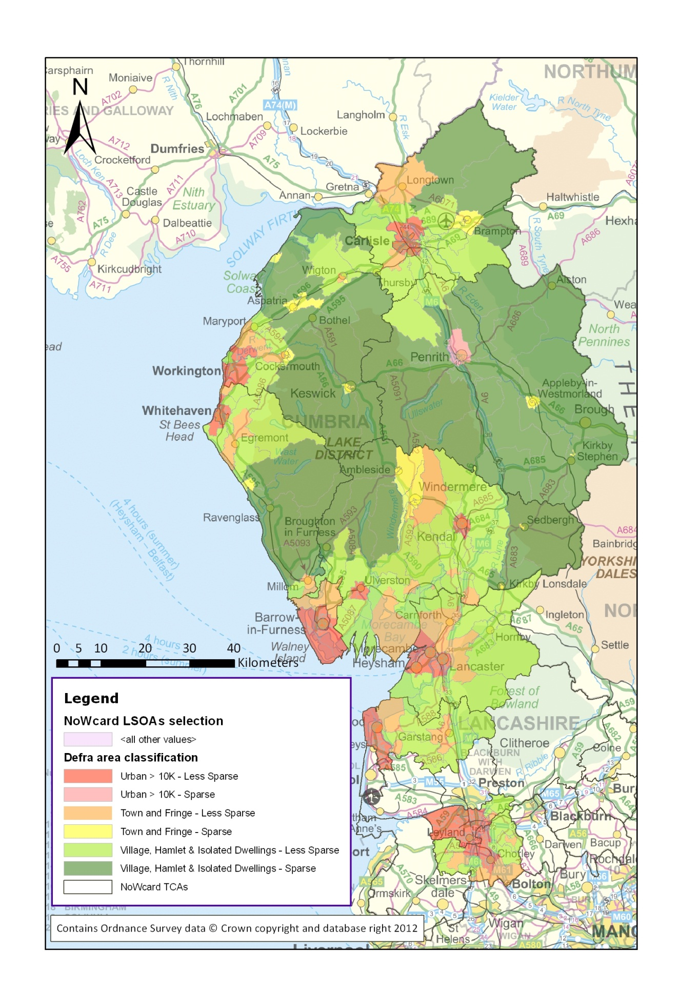
Figure 4.4: ONS Classification applied to the 10 Selected NoWcard TCAs

Passholder and Journey Characteristics

Overview

As described above, NoWcard provided MVA Consultancy with data on approximately 190,000 passholders recorded as resident in the 10 Districts as at August 2010. Of these, approximately 128,000 were recorded as making at least one concessionary journey within the NoWcard area in the 52 weeks from September 2009 and August 2010 inclusive.

The estimated total number of passholders is based on records of cards issued over a period from November 2007 to August 2010, and may include passholders who have deceased or moved away. The total will also include passholders who obtained their pass towards the end of the year for which journeys are recorded, and journey numbers will not therefore represent a full year of journey making by these individuals. It is not possible to be definitive about the number of passes issued during the 52 week period, but estimates based on the available information suggest that about 16,000 of the 190,000 cards were issued during that time, although these may not all be the first cards issued to individual passholders.

It is estimated that in total these passholders made about 12.2 million concessionary journeys using their English National Concession pass in the NoWcard area in the 52 week period. The average number of journeys made per week was therefore about 1.21; if journey making and passholders who appear to have had a card issued during the 52 week period are excluded, this average rises to 1.278. Of passholders making at least one journey in the 52 week period, the average number of journeys per week was about 1.83, which rises to 1.90 if “new” passholders are excluded.

These journey numbers are based on recorded smartcard transactions, after expansion to allow for a proportion of transactions which have not been included in the journey database for various reasons. As discussed in the previous chapters, these are principally to do with equipment failures or card errors. Un-weighted journey numbers are about 11.8 million, with an aggregate manual transaction expansion factor of 1.029 producing an estimated 12.2 million ‘weighted’ journeys.

It should also be recalled that the total journey numbers analysed here will exclude journeys made by non-NoWcard residents on buses in the NoWcard area, and also journeys made by NoWcard residents outside the NoWcard area. In all instances discussed here, “journeys” are defined as instances of a single ride on a bus for which a single fare transaction has been made, so if a passholder needs to change buses to get from his or her origin to destination, this will generally be recorded as two journeys.

The overall figure of 1.278 journeys per week (based on all passholders, with cards issued before 1 September 2009) can be compared with the average journeys per week estimated from the initial tranche of NoWcard data analysed as part of the ITS study for DfT (the “ITS” dataset). The average derived from that data was 1.336 journeys per week, based on cards issued prior to the 5-week period in February-March 2009 over which journey data was collected.

There are likely to be a number of factors which explain the difference in the average journey rate between the two NoWcard samples, but it has not been the role of this study to investigate explanatory variables. Amongst these are differences arising from the 5-week and whole-year nature of the datasets, as well as seasonal factors that might affect the representativeness of the initial five-week period. In addition, the later (full year) dataset includes periods of extreme weather in November 2009 which led to substantial localised flooding in Cumbria, and snow and ice that severely affected travel in both Lancashire and Cumbria in December 2009 and 2010.

Variations in Concessionary Travel Behaviour

Figure 5.1 shows the distribution of total journeys per annum from each individual postcode in the ten selected TCAs – about 21,000 postcodes in total, sorted alphabetically and numerically (eg so CA1 – central Carlisle – is the first record in the sample) so that postcodes in the same town or city can be identified graphically. In addition to the variation in total concessionary travel demand, the disparities between different towns and cities, and the more rural areas in between them, is clear.
Figure 5.5: Total Journeys per Annum by Postcode

Table 5.1 summarises cardholding and usage for each of the ten Districts, illustrating some significant differences between them, or, perhaps more importantly, differences in their geography and area characteristics. Note that the journey rates shown are per journey-making passholder (i.e. passholders making at least one journey per year and hence appearing on the Journeys database as a customer). The Table reports all journeys, and all recorded customers, including those with passes issued during the period of journey data collection.
Table 5.6: Passholders and Journeys by District
District | County | NoWcard CMS passholders | Journeys database unique customers | Percentage of Cardholders making journeys | Weighted Journeys | Average Weighted Journeys per journey-making passholder
Chorley | Lancashire | 19,289 | 12,350 | 64% | 1,007,551 | 81.6
Lancaster | Lancashire | 28,897 | 19,143 | 66% | 2,183,375 | 114.1
South Ribble | Lancashire | 22,167 | 15,228 | 69% | 1,333,885 | 87.6
Wyre | Lancashire | 28,333 | 18,213 | 64% | 1,544,835 | 84.8
Allerdale | Cumbria | 18,539 | 12,192 | 66% | 1,007,910 | 82.7
Barrow-in-Furness | Cumbria | 14,256 | 10,558 | 74% | 1,209,497 | 114.6
Carlisle | Cumbria | 19,738 | 15,773 | 80% | 2,229,626 | 141.4
Copeland | Cumbria | 9,303 | 6,410 | 69% | 675,317 | 105.4
Eden | Cumbria | 8,777 | 4,916 | 56% | 196,884 | 40.0
South Lakeland | Cumbria | 23,602 | 13,248 | 56% | 778,533 | 58.8
Total |  | 192,901 | 128,031 | 66% | 12,167,415 | 95.0

The average number of journeys made per year per passholder varies considerably. The residents of Carlisle make the most, whereas the very rural Districts in Cumbria make the least. It is interesting that the Lancashire districts fall in the middle of this range, and it would be useful to explore further the differences in journey making between Carlisle and Lancaster, the two biggest urban areas in the dataset.

Although Table 5.1 is of interest in displaying differences in journey making between the Districts, the average journey rates shown are not a reliable guide to the absolute levels of journey making because of the inclusion of cardholders joining the scheme partway through the year. Table 5.2 provides a more accurate measure of absolute average journey rates, showing passholder (and journey) numbers for passholders where the date of first issue is thought to be before 1 September 2009. These passholder numbers are therefore smaller than those quoted elsewhere in this report for the total number of passholders present in the dataset, which include all those issued up to and including August 2010.The journeys numbers are based on expanded values which include an allowance for missed transactions.
Table 5.7: Journeys per week by Defra/ONS Area Type
Passholders and Journeys where pass issued before 1/9/’09 | Sparse |  |  |  | Less Sparse |  |  |  | Total (includes not otherwise allocated)
Passholders and Journeys where pass issued before 1/9/’09 | Urban >10K | Town and Fringe | Village | Hamlet and Isolated Dwelling | Urban >10K | Town and Fringe | Village | Hamlet and Isolated Dwelling | Total (includes not otherwise allocated)
Passholders and Journeys where pass issued before 1/9/’09 | 1 | 2 | 3 | 4 | 5 | 6 | 7 | 8 | Total (includes not otherwise allocated)
Passholders | 2,719 | 7,466 | 6,151 | 3,783 | 108,311 | 28,120 | 14,312 | 5,786 | 176,858
Journeys (1000s) | 91.8 | 262.2 | 143.0 | 65.0 | 8,970.8 | 1,545.3 | 497.7 | 168.8 | 11,753.7
Journeys per week | 0.649 | 0.675 | 0.447 | 0.331 | 1.593 | 1.057 | 0.669 | 0.561 | 1.278

The average number of journeys per week decreases with the level of urbanisation, as would be expected, and is consistently larger for areas classified as “less sparse” compared to the equivalent area type classified as “sparse”. It is important to note that a host of factors is likely to influence the differences in journey making captured by the differences in area type, of which the most significant is likely to be the availability of bus services.

The variation in average journeys per week is highly likely to be associated with differences in relative frequencies and hence propensity to purchase discount tickets. The data therefore confirms the desirability of deriving lookup tables so that the area type characteristics of individual Travel Concession Authorities can be reflected in the calculation of fare discount factors

Compared with Defra/ONS area types, the distribution of passholders across the NTS area type classification is somewhat more uniform, as shown in Table 5.3. Note that the very few passholders associated with the NTS area type 11(“Non-Met urban 100K to 250K”) have been included in the “otherwise not allocated” category”, since the statistical robustness of data associated with these passholders will be very limited.
Table 5.8: Journeys per week by NTS Area Type
Passholders and Journeys where pass issued before 1/9/’09 | Non-Metropolitan Urban |  |  |  |  | Rural | Total (includes not otherwise allocated)
Passholders and Journeys where pass issued before 1/9/’09 | Over 250K | 50K to 100K | 25K to 50K | 10K to 25K | 3K to 10K | Rural | Total (includes not otherwise allocated)
NTS Type | 10 | 12 | 13 | 14 | 15 | 16
Passholders | 44,770 | 32,445 | 19,140 | 13,641 | 25,979 | 40,673 | 176,858
Journeys (1000s) | 3,047.2 | 3,569.4 | 1,509.2 | 900.0 | 1,276.9 | 1,441.9 | 11,753.7
Journeys per week | 1.309 | 2.116 | 1.516 | 1.269 | 0.945 | 0.682 | 1.278

In contrast to the Defra/ONS classification, the NTS area types are more detailed at the urban end of the scale. The average journey rate for the largest urban settlements is less than for the next largest, which seems most likely to reflect the fact that the NoWcard areas allocated to this are type are unlikely to be representative of the generality of denser, larger urban areas. Otherwise journey rates decrease with level of urbanisation (and associated characteristics) as would be expected.

Frequency Distribution of Journeys

The frequency with which passholders make journeys varies considerably between passholders. The DfT discounted fare methodology uses the relative proportions of passholders making journeys with different frequencies to estimate the likely take up of discount fares by concessionary passholders in the absence of the concession. The data shows that many passholders make very little use of the free concession, while a small minority of passholders make very frequent use of their passes

Figure 5.2 shows the distribution of average journeys per week amongst all cardholders in the ‘Journeys’ database i.e. those making at least one journey in the year. Average weekly usage follows a negative exponential distribution, with 22 cardholders making an average of 30 journeys or more per week, and 32% making an average of 0.0 to 0.2 journeys per week.
Figure 5.6: Distribution of journey frequency by passholders making at least one journey

An alternative way of viewing the frequency distributions is from the perspective of the proportions of passholders making the most journeys. This is illustrated in Figure 5.3, which is based on all passholders who were first issued with a pass before 1st September 2009, including those making no journeys in the one year period.
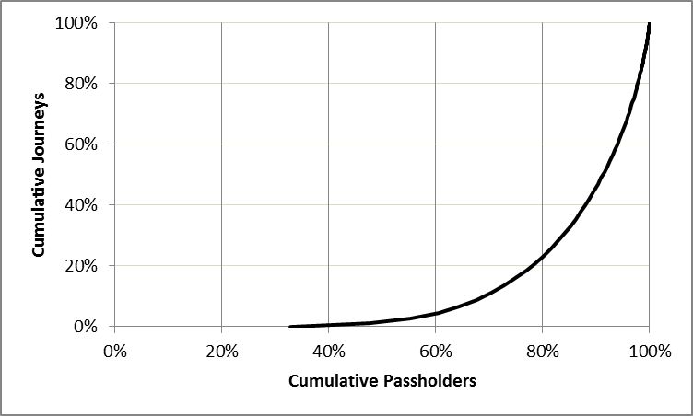
Figure 5.7: Cumulative passholder numbers plotted against cumulative journeys

It can be seen that virtually no journeys were made by 40% of passholders, and 80% of passholders accounted for only 20% of the total number of concessionary journeys made. In contrast, the remaining 20% of passholders made 80% of all concessionary journeys.

The relative frequency with which passholders use the concession are summarised in Table 5.4. The frequency categories have been selected to be comparable with the published outputs from the National Travel Survey. The data excludes passholders whose pass was issued after 31st August 2009.
Table 5.9: Passholder Journey Frequencies
Frequency of Use | Passholders |  | Journeys |  | Journeys per week
Frequency of Use | Number | % of total | Number | % of total | Journeys per week
Less than once a year or never | 58,547 | 33.1% | 0 | 0.0% | 0
1 or more per year but less than 1 per month | 29,096 | 16.5% | 146,757 | 1.2% | 0.097
1 or more a month but less than 1 per week (pw) | 32,941 | 18.6% | 932,222 | 7.9% | 0.544
At least once a week | 56,274 | 31.8% | 10,674,740 | 90.8% | 3.648
Total of all passholders | 176,858 | 100.0% | 11,753,719 | 100.0% | 1.278
All passholders making at least one journey in the year | 118,921 | 67.2% | 11,753,719 | 100.0% | 1.901
Less than 1pw | 62,647 | 35.4% | 1,078,979 | 9.2% | 0.331
1 or more but less than 5 pw | 44,038 | 24.9% | 5,547,897 | 47.2% | 2.423
5 or more but less than 10 pw | 9,921 | 5.6% | 3,511,135 | 29.9% | 6.806
10 or more but less than 15 pw | 1,790 | 1.0% | 1,102,756 | 9.4% | 11.847
15 or more but less than 20 per week | 387 | 0.2% | 338,102 | 2.9% | 16.801
20 or more per week | 138 | 0.1% | 174,850 | 1.5% | 24.366

Note: data relates only to passholders and journeys where the pass was first issued prior to 1st September 2009

Overall, a third of passholders made no journeys using the concession during the year, and a further 16.5% of passholders made fewer than one journey per month. At the other extreme, 6.9% of passholders made 43.7% of all concessionary journeys.

These proportions can be compared with those found by the National Travel Survey, and the previous analysis of five weeks of NoWcard data carried out as part of the ITS study. Some differences in the outcomes are to be expected given the different characteristics of the underlying datasets:
- the more recent data from NoWcard is of course for a full year, and will therefore have more scope for capturing infrequent journeys than the earlier NoWcard analysis of only five weeks;
- the annual data will reflect the full range of seasonal influences within the year;
- the NTS data comes from a sample survey and relies upon respondent reporting of journey frequencies, whereas the smartcard data provides a complete picture of journey making. With other sample surveys, there tends to be some reporting bias because there is greater participation by “active” travellers compared to non-users; and
- NTS is a national survey designed to be representative of England as a whole, and is therefore weighted towards larger centres of population, where public transport use is likely to be greater on average than in the NoWcard area.

The figures are summarised in Table 5.5.
Table 5.10: Comparisons of Passholder Journey Frequencies
Frequency of Use | NoWcard September 2009-August 2010 |  | NoWcard February-March 2009 |  | NTS 2010
Frequency of Use | Passholder % of total | Journey % | Passholder % of total | Journey % | Passholder %
Less than once a year or never | 33.1% | 0.0% | 56.2% | 0% | 31%
1 or more per year but less than 1 per month | 16.5% | 1.2% | 56.2% | 0% | 15%
1 or more a month but less than 1 per week | 18.6% | 7.9% | 16.9% | 6.7% | 15%
At least once a week | 31.8% | 90.8% | 26.9% | 93.3% | 39%
1 or more but less than 5 pw | 24.9% | 47.2% | 18.5% | 36.0% | n/a
5 or more but less than 10 pw | 5.6% | 29.9% | 7.7% | 47.1% | n/a
10 or more but less than 15 pw | 1.0% | 9.4% | 7.7% | 47.1% | n/a
15 or more but less than 20 per week | 0.2% | 2.9% | 0.5% | 6.1% | n/a
20 or more per week | 0.1% | 1.5% | 0.2% | 4.1% | n/a
Average Journeys per week | 1.278 |  | 1.336 |  | 1.519

Overall, the frequency distributions are broadly similar across all three datasets, with a similar pattern of large proportions of non-users and relatively small proportions of passholders making a high proportion of concessionary journeys.

Differences between the proportions are generally as would be expected, with, for example, the annual coverage of the more recent NoWcard data leading to smaller proportions of non-use compared to the earlier NoWcard analysis. The biggest differences between the two NoWcard analyses are in the proportions of passholders making between one and five journeys per week on average, which are more heavily represented in the newer NoWcard analysis.

Although not directly reported by NTS, an overall average value for journeys per week has been inferred from the reported frequency proportions, and appropriate averages for each category calculated from the most recent NoWcard data. This suggests that NoWcard passholders on average make about 15% fewer concessionary journeys than passholders across England as a whole.

Other variations in journey making characteristics

Table 5.6 summarises differences in usage by gender and disability. Unfortunately, validated data on the personal characteristics of non-user passholders was not available, and therefore this analysis is only of active passholders making at least one journey in the year. Of these, 58% were female, and 8.3% had their pass because of disability. On average females made 8% more journeys per week than males, and disabled passholders made 85% more journeys per week than those who had their pass because of age. Overall, disabled passholders made 14.3% more journeys than older passholders.
Table 5.11: Concessionary Pass Usage by Gender and Disability
Segment | Passholders making at least one journey in the year | Total Weighted Journeys | Average Journeys per Week per active passholder
Female | 74,830 | 7,358,396 | 1.891
Male | 53,201 | 4,809,019 | 1.738
Disabled | 10,593 | 1,740,223 | 3.159
Not disabled | 117,438 | 10,427,192 | 1.707
Note: data refers to all passholders, including those newly issued with a pass during the year

Figure 5.4 shows that amongst active passholders, average usage of the concessionary travel pass by age band follows a normal distribution, with journey-making increasing up to the age of 75 to 79, before plateauing at age 85 to 89, and then declining.
Figure 5.8: Distribution of Average Journeys per Week by Age Band

These patterns of relative frequency by age and gender are very similar to those reported in the earlier ITS work.

Derivation of Look up Tables

Overall Process

The “cleaned” datasets produced by MVA consists of two large Excel spreadsheets, one each for data from Cumbria and Lancashire passholders respectively. The core data was set out in two distinct worksheets, reporting the number of concessionary journeys made by each passholder in each day of the reported year. One contains “unweighted” journey data (as tabulated directly from the “raw” journey data), the other contains “expanded” journey numbers in which raw journey numbers have been multiplied by an expansion factor to adjust for transaction failures and missing data. Note that 364 days of data are included, since no journeys were made (and no service would have been provided) on Christmas Day, 25th December 2009.

These worksheets are very sizeable, with up to about 65,000 rows (one for each passholder) in each “County” dataset, and nearly 800 columns for passholder and associated journey data, and derivations thereof. The latter contains many blank or zero-value cells because no journeys would have been made by an individual passholder on a particular day.

To facilitate processing, versions of these files were generated containing only a passholder sequence number, area type classifications, and the journey data. Four further worksheets were then created, each containing non-overlapping subsets of no more than 20,000 passholders, since it was found that this was the practical problem size limit of Excel 2010 for downstream look-up table derivation. A standard processing template was developed into which each of these data subsets was copied. Initially, this analysis focussed on weighted journey data only, but additional analysis was then carried out which established look-up tables from un-weighted data for comparison purposes.

The spreadsheet is constructed to enable the look up table to be constructed on an iterative basis, in which each iteration derives results for a given weekly price ratio, i.e. the average price of a weekly ticket divided by the average price of a cash ticket. The results are:
- the number of weeks in which a weekly ticket would have been bought (based on whether the number of journeys made in a particular week by a particular passholder is equal to or exceeds the weekly price ratio); and
- the associated number of journeys;
and for each of ten possible daily price ratios (from 1 to 10):
- the number of days in which a daily ticket would have been bought ((based on whether the number of journeys made in a particular day by a particular passholder is equal to or exceeds the daily price ratio);
- the associated journeys; and
- the journeys that would not be associated with either a daily or weekly ticket.

In effect, each iteration generates one line of the look up table, for a given weekly price ratio. Successive iterations build up the look up table so that values are available for all price ratios from 1 to 40.

Data selection issues

As discussed in Chapter 3, great care was taken to validate and check the supplied data, and it was not initially clear whether some data should be excluded from the construction of look-up tables. The conclusions to which we came were as follows.
Inclusion of journeys made on “hot-listed” cards.

“Hot-listing” means identification of a card as being associated with a particular problem which should lead to its withdrawal. There is a variety of reasons for which individual cards might be “hot-listed”, including loss or theft, but although the hot-listing system is primarily there to help prevent fraud, in many instances a card might be flagged as “hot” for other reasons that are not fraud related, e.g. as cards are replaced due to wear, tear, or loss throughout the year.

Following an examination of hotlisting issues it was concluded that it was likely that journeys associated with hot-listed cards were genuine and not fraudulent, and that it would be more appropriate to include journeys made on hot-listed cards in look-up table construction than to exclude them. This is especially true as cards which were recorded as ‘hot’ at the end of August 2010 may have become so during the year, and their exclusion would remove completely valid journeys undertaken prior to the card becoming ‘hot’.
Inclusion of journeys made on cards not matching customer references found on the Card Management System

There was initially some concern that significant numbers of card references included in journey transaction records could not be matched to equivalent cards in the NoWcard Card Management System database. Further investigation revealed that the problem arose from inconsistent data formatting, which was subsequently resolved, leading to a very high proportion of matches between the journey and CMS databases. The remaining failures to match cards between datasets almost certainly arise from a variety of timing issues which in themselves have no significance, and it was concluded that there is no reason why these journey records should be excluded from look up table construction.
Inclusion of journeys made by passholders with cards initially issued during the “data year”.

Error conditions apart, no journeys should be recorded prior to the date of issue as being made by passholders who acquired a pass part way through the data year (eg September 2009 to August 2010). Many weeks of zero journeys that precede issue of a pass will not reflect genuine observations of no journeys having been made despite access to the concession.

Inclusion of these passholders could create some bias with regard to estimates of the absolute numbers of journeys made, and hence they have been excluded from the estimates of average weekly journeys and other measures of journey making discussed in the previous Chapter. However, the inclusion of weeks of blank data will not affect the derivation of look-up tables. This is because weeks of zero journeys are not material to the construction of look up tables, which are only concerned with the potential for purchase of cash, daily and weekly tickets, in which each week is treated in isolation. Consequently the nominal inclusion of weeks of observations prior to a pass being issued will have no impact on output look-up tables.

The inclusion of the week in which a pass is issued is, potentially, of more relevance, since a new pass is only likely to become available for use part way through the week. Overall, this effect is felt unlikely to be of any significance, but in any case precise data on exactly when individuals obtain their pass is not available because of batch-processing of entries into the CMS database. Consequently it is not possible to confidently identify relevant journey records which may reflect a “part-week” of pass availability and no attempt has been made to exclude observations of journeys made in part-weeks of pass availability.
“Unweighted” or “Weighted” Journey Data

Of the various data issues, the most difficult and potentially most significant question is whether look up tables should be constructed from “un-weighted” or “weighted” data.

The un-weighted data takes the form of an integer number of journeys counted as those made by a specific passholder on a particular day within the data year, and derived directly from smartcard transaction data. It will not include any journeys actually made that were not recorded on the various smartcard systems for a variety of reasons, principally on-bus equipment failure, or card-related errors. Although not recorded via the smartcard system, bus operators will nevertheless be able to estimate the number of such transactions, since their reimbursement payments will depend upon accurate estimates of total journey volumes. This additional data has been used to calculate expansion factors (“weights”) which have been applied to appropriate subsets of the recorded smartcard journey data.

As a simple example, suppose that the actual journeys made (e.g. by a given passholder) on successive travel days were three journeys a day over a seven day period, giving 21 journeys in total actually made. Suppose that the journeys made on one of those days were not recorded, so that a total of 18 journeys were recorded in contrast to the independent estimate of 21 journeys made by the operator. An expansion factor of 21/18 is calculated, and the expanded data would show 3 * 21/18 (3 * 1.167 = 3.5) journeys having been made by that passholder on each of the six days for which journeys were recorded. Zero journeys would be shown for the day on which there was the recording failure.

If look-up tables are based on expanded data, it is inevitable that the frequency with which discount tickets will appear to be attractive will be greater than if look-up tables are based on raw (i.e. unexpanded) data. However, the raw data is of course not an accurate reflection of the journey patterns actually made by passholders, because some of these journeys have not been recorded. Raw data may understate the apparent frequency with which discount tickets will be purchased, relative to the true (but unobservable) pattern of journeys, whereas expanded data is likely to overstate the apparent frequency with which discounted tickets would be purchased.

It is not clear a priori whether use of raw or expanded data will lead to the least biased estimates of discount factors. In principle, the direction of impact depends largely on the pattern of missed transaction, and the distribution of the size of individual expansion factors. If missed transactions are distributed relatively uniformly and are modest in size, then it is likely that use of expanded data is the best approach. On the other hand, if recording failures are “lumpy” and lead to a lack of recorded transactions on a number of days, then individual expansion factors will be larger (because they can only be applied to days on which at least some journeys are recorded) and could easily distort the simulation of choice of ticket types. The overall scale of expansion is only about 3%, but individual expansion factors can be substantially greater than this.

As reported in the next Chapter, the choice of look-up tables derived from un-weighted or weighted data can have a significant impact on discount factors, and an arbitrary choice could easily lead to bus operators being either better or worse off. Further analysis is therefore required, with one possible line of investigation being the simulation of differing patterns of transaction failure, and evaluation of alternative strategies of using weighted or un-weighted data to construct look-up tables.

Detailed derivation of look-up tables

In order to work within practical computing limitations, the standard spreadsheet developed to derive look-up tables focuses all significant computation on a single sheet, in which each row is associated with the journeys of an individual passholder. Each row contains a passholder reference number (only required for diagnostic purposes), limited passholder data, and the two area type classifications (“ONS” and “NTS”) obtained from the passholder’s residential postcode. A further 364 spreadsheet cells contain the observed journey totals for each day. For most passholders, most of these cells are blank or zero, reflecting the fact that no journey transactions involving the passholder’s card were recorded on any of the NoWcard bus operators’ services on these days. Non-zero cells give the number of journeys that were recorded on NoWcard operator services on those days. This is the core observed data on journey making provided by the NoWcard consortium.

A further 364 cells (for each passholder) are linked to the observed daily journeys. The value in the cells is determined by the sum of the observed journeys made in the week in which the specific day falls. If the sum of journeys in the week is equal to or greater than an externally set Weekly Price ratio, the passholder is assumed to purchase a weekly ticket. The text value “W”, is used as a marker for the fact that a weekly ticket would be used for these days. Otherwise the value of the cell is set to be the same as that observed (which will often be zero). These are known as “Post-weekly” journeys.

The Weekly Price Ratio is the price of a weekly ticket measured as a multiple of the average price per journey of a cash journey. It represents the number of journeys in a week at which it is cheaper to purchase a weekly ticket rather than make the same number of journeys using individually purchased cash tickets. The way that the formulae are structured, the spreadsheet in effect divides the observed journeys made by a passholder into seven-day blocks, stretching over the 364 days of the observation period. For simplicity, the “week” which includes Christmas Day (on which no journeys were recorded) is stretched to eight calendar days, so that the 364 observed days all fit exactly into 52 weeks. The start and end of these weeks is obviously arbitrary, but it was considered that there would be little benefit from the complications associated with using more conventional week definitions (eg Monday through Sunday).

The process is illustrated in simplified form in Table 6.1.
Table 6.12: Example of Spreadsheet Calculation
A | B | C | D | E | F | G | H | I
 |  | Week beginning
Passholder sequence number | Area type | 1-9-09 | 2-9-09 | 3-9-09 | 4-9-09 | 5-9-09 | 6-9-09 | 7-9-09
 | Observed journeys per day |  |  |  |  |  |  |  | (Total)
Nnnn1 | A | 3 | 1 | 1 | 1 | 2 | 0 | 3 | (11)
Nnnn2 | B | 0 | 0 | 5 | 2 | 2 | 0 | 0 | (9)
Nnnn3 | C | 2 | 3 | 6 | 2 | 2 |  | 2 | (17)
(Column reference) | XC | XD | XE | XF | XG | XH | XI | XJ
 | Post-weekly journeys per day if Weekly Price Ratio = 10
Nnnn1 | A | W | W | W | W | W | W | W | (0)
Nnnn2 | B | 0 | 0 | 5 | 2 | 2 | 0 | 0 | (9)
Nnnn3 | C | W | W | W | W | W | W | W | (0)

The top half represents a left-hand section of the spreadsheet. The passholder sequence number provides a link to other passholder data, not directly used in constructing the look-up tables. The observed journeys per day are shown for the first week of the data period, which runs from 1 September 2009 to 7 September 2009, in columns C to I. The total journeys made in this week for the three passholders shown are 11, 9 and 17 respectively. Consequently, if the Weekly Price Ratio is (for example) 10, then the relevant columns representing “post-weekly” journeys will be set as “W” for passholder Nnnn1 and Nnnn3, but for passholder Nnnn2 the observed journey values are retained.

The information in this worksheet provides a complete picture of the weekly ticket sales, weekly journeys, daily ticket sales and daily journeys, and (by inference) the cash journeys, for a given Weekly Price Ratio, and for a range of Daily Price Ratios for each passholder in the included data. The post-weekly journeys can then summarised using Excel COUNTIF and SUMIF functions. The journeys per day are included if the journeys for a given day are greater than or exceed a given Day Ticket Price Ratio. Separate counts and summations of journeys are carried out for each day price ratio between 1 and 10. In addition, the number of “W” values is counted, and the associated number of journeys made by weekly tickets is calculated by taking the difference between the total observed journeys and the total of post-weekly journeys.

The value of the Weekly Price Ratio is set in the second worksheet of the spreadsheet, which analyses these results through a series of SUMIF expressions in which the inclusion criteria is the area type. The output is a Results Table, part of which is shown in Table 6.1, which for a given Weekly Price Ratio shows:
- the total number of weeks in which the journeys made by passholders is greater than or exceeds the Weekly Price Ratio (from 1 to 40), and the total number of journeys made in these weeks. These are assumed to be the journeys that would be made using a weekly ticket (and therefore would not be made using cash or a daily ticket); and
- and for each Daily Price Ratio (from 1 to 10), the number of days not assigned to weekly tickets in which the journeys are equal to or greater than the daily price ratio, and the total number of associated journeys; and the number of journeys not otherwise assigned to weekly or daily tickets.

These values are totals for all passholders assigned to each area type, some of which are illustrated in the Table. The spreadsheet looks for passholders and associated journeys in all possible area types, even though (depending on the subset of passholders under analysis) some potential area types may not be represented.

The values displayed in the Results Table are dependent upon the Weekly Price Ratio, for which a number of different values need to be displayed in the final Look-up Table. A macro is therefore incorporated in the spreadsheet which successively increases the Weekly Price Ratio from 1 to 40. The macro copies the values in the Results Table to a blank part of the worksheet before incrementing the Weekly Price Ratio, so that as it progresses a large set of results are built up, encompassing all area types, all Weekly Price Ratios and all Daily Price Ratios. Each iteration involves a very substantial volume of computation, and consequently with larger data subsets (eg of 20,000 passholders) a non-negligible elapsed time is required.

Consolidation of Look-up Tables

The standard spreadsheet creates a 756 row by 40 column array of values generated by the above procedure for a given subset of passholder and journey data. A total of eight such spreadsheets are required to process the data from approximately 65,000 Lancashire passholders and 63,000 Cumbria passholders. Note that these passholder numbers represent only those passholders who available data suggests made at least one smartcard-recorded journey in the 364 day period.

The worksheet containing the results for each passholder subset have been copied into a further spreadsheet, and the results from the subsets consolidated into an identically structured results table representing all passholders from each County. The results sheet as generated from the individual passholder data is in order of Weekly Price Ratio. A final step is therefore to rearrange the rows of the consolidated results table so that a series of complete Look-up tables are available, in order of area type. This involves sorting the rows in sequence by area type, and then by Weekly Price ratio. The result is a look-up table, part of which is illustrated in Figure 6.2, which is in the same format as that of DfT’s calculator.

Figure 6.9: Example of results from analysis of passholder data (fragment)
Figure 6.10: Example of output Look-up Table (fragment)

Price Ratio Limits

The requirement from DfT was for the provision of look-up tables encompassing up to 10 daily price ratios and up to 40 weekly price ratios. The structure of the look-up tables provides for 39 rows of data for each weekly price ratio from 1 to 39 inclusive. Each row contains:
- the number of weekly tickets that it is estimated would be sold for the given weekly price ratio, plus the associated number of journeys;
- the number of journeys that would be made using cash fares if there were no daily ticket. For consistency with the structure of the look-up table currently incorporated into the DfT Reimbursement calculator, two columns of “daily tickets” and “daily journeys” have been included in the look-up table, but these are set to zero; and
- then for each daily ticket ratio from 1 to 10, the number of daily tickets sold, the number of associated journeys, and the number of cash journeys – i.e. those made neither by weekly or daily tickets.

Each instance of a given weekly ticket price ratio and weekly ticket price ratio represents a simulation of how the entirety of the passholders represented in the look-up table would distribute their journeys between the three different ticket types. An important check on the completeness of the look-up table and any subsequent manipulations is therefore that the total number of journeys (i.e. the sum of those made by each of the three ticket types) should be identical for all price ratio combinations.

The construction of the look-up table is such that the journeys allocated to the highest price ratios include all journeys in which the number of journeys is equal to or exceeds the price ratio. So weekly tickets and journeys in the last row of the look up table represents passholders making 40 or more journeys per week, and the last set of columns represents passholders making 10 or more journeys per day.

It is assumed that the application of the look-up table is such that if the user inputs a zero price, this is interpreted as indicating the non-availability of a given ticket type. Consequently, in the first row of the look-up table, which is shown as a weekly ticket price ratio of zero, no journeys are assigned to weekly tickets and all are assigned to daily tickets or cash fares.

Applying the Look-up Tables

The fundamental deliverables from this project are look up tables which have been delivered in spreadsheet form to DfT. They are incorporated into a single workbook (provided to DfT in the file named “20120503 New NoWcard Tables V3.xlsx”), with separate worksheets for the following sets of look-up tables:
- New NoWcard (10 Districts, Sep ’09 to August ’10), weighted
- New NoWcard (10 Districts, Sep ’09 to August ’10), unweighted
- Lancashire (4 Districts, Sep ’09 to August ’10), weighted
- Lancashire (4 Districts, Sep ’09 to August ’10), unweighted
- Cumbria (6 Districts, Sep ’09 to August ’10), weighted
- Cumbria (6 Districts, Sep ’09 to August ’10), unweighted.

In addition the spreadsheet includes two further look-up tables for:
- 5-weeks of the new Lancashire NowCard data for the periods 21st February 2010 to 27th March 2010. This corresponds to the five weeks in 2009 from which the initial Nowcard data was drawn, and will enable DfT to examine changes in the implied discount factors for equivalent periods one year apart; and
- New NoWcard (10 Districts, Sep ’09 to August ’10) sum of weighted and unweighted tables, in effect providing an average of the look-up tables drawn from weighted and un-weighted data.

Each worksheet is identically structured and contains, in rows 78 to 774, 17 distinct look-up tables, each of which consists of 41 rows (for weekly price ratios “None” to 40, and daily price ratios “None” to 10). The first of these look-up tables summarises data from all available passholder records associated with journey-making in the 52 weeks of the data period. The subsequent tables summarise data from various subsets of the total, with passholders selected on the basis of the area type of the passholder’s place of residence. There are 7 tables based on NTS area type classifications, and 8 based on ONS/Defra classifications, plus (for completeness) one for passholders for which it was not possible to establish an area type.

Where the total number of passholders in a subset (e.g. for a particular area type) is less than 1,000, the relevant table values have been set to zero to avoid any possible danger that the data could be used to reveal information about individual passholders. However, data on these passholders, and also for those passholder for whom it was not possible to identify an area type, are included in the look-up table representing all passholders in the dataset. The passholder and journey totals associated with each data subset is summarised in Table 6.1. It can be seen that the new NoWcard data as a whole provides good coverage of NTS area types 10, and 12 to 16, and all 8 classifications defined in the Defra/ONS typology, but there is less uniform coverage in each of the County subsets.

Table 6.1: Summary of Passholder and Journey Totals Included in each of the deliverable Look-up Tables
Passholder and Journey totals included in Look-up tables |  |  | Lancashire and Cumbria Combined ("New NoWcard") |  |  | Lancashire |  |  | Cumbria
Class-ification | Area Type | Area Type Description | Pass-holders | Weighted Journeys | Un-weighted journeys | Pass-holders | Weighted Journeys | Un-weighted journeys | Pass-holders | Weighted Journeys | Un-weighted journeys
All | Total | Total | 128,031 | 12,167,415 | 11,825,602 | 64,934 | 6,069,647 | 5,953,585 | 63,097 | 6,097,768 | 5,872,017
NTS | 10 | Other urban over 250K | 33,250 | 3,149,822 | 3,090,863 | 33,249 | 3,149,811 | 3,090,852 | 0 | 0 | 0
NTS | 11 | Other urban 100K to 250K | 0 | 0 | 0 | 0 | 0 | 0 | 0 | 0 | 0
NTS | 12 | Other urban 50K to 100K | 26,758 | 3,710,138 | 3,776,361 | 14,308 | 1,678,012 | 1,811,571 | 12,450 | 2,032,126 | 1,964,790
NTS | 13 | Other urban 25K to 50K | 15,051 | 1,555,086 | 1,490,474 | 0 | 0 | 0 | 15,050 | 1,554,995 | 1,490,419
NTS | 14 | Other urban10K to 25K | 10,146 | 931,623 | 870,819 | 1,852 | 118,415 | 91,413 | 8,294 | 813,208 | 779,406
NTS | 15 | Other urban 3K to 10K | 18,012 | 1,317,732 | 1,197,643 | 7,767 | 591,554 | 497,262 | 10,245 | 726,177 | 700,381
NTS | 16 | Rural | 24,661 | 1,492,128 | 1,387,057 | 7,667 | 526,129 | 455,086 | 16,994 | 965,999 | 931,971
NTS | Not allocated |  | 153 | 10,886 | 12,385 | 91 | 5,725 | 7,401 | 64 | 5,263 | 5,050
Defra/ONS | 1 | Urban >10k - Sparse | 2,025 | 95,864 | 91,366 | 0 | 0 | 0 | 2,025 | 95,864 | 91,366
Defra/ONS | 2 | Town and Fringe - Sparse | 4,967 | 269,698 | 260,120 | 0 | 0 | 0 | 4,967 | 269,698 | 260,120
Defra/ONS | 3 | Village - Sparse | 3,550 | 147,656 | 142,541 | 0 | 0 | 0 | 3,550 | 147,656 | 142,541
Defra/ONS | 4 | Hamlet & Isolated Dwellings - Sparse | 1,986 | 68,078 | 65,206 | 0 | 0 | 0 | 1,944 | 66,673 | 64,541
Defra/ONS | 5 | Urban >10K - Less Sparse | 83,787 | 9,290,110 | 9,170,906 | 49,800 | 4,969,143 | 5,011,736 | 33,987 | 4,320,967 | 4,159,170
Defra/ONS | 6 | Town and Fringe - Less Sparse | 19,735 | 1,594,019 | 1,452,419 | 10,192 | 786,030 | 673,406 | 9,543 | 807,989 | 779,013
Defra/ONS | 7 | Village - Less Sparse | 8,627 | 514,127 | 469,104 | 3,254 | 208,761 | 174,495 | 5,373 | 305,366 | 294,609
Defra/ONS | 8 | Hamlet & Isolated Dwellings - Less Sparse | 3,202 | 177,223 | 161,874 | 1,557 | 98,920 | 86,256 | 1,645 | 78,303 | 75,618
Defra/ONS | Not allocated |  | 152 | 10,640 | 12,066 | 131 | 6,794 | 7,692 | 63 | 5,252 | 5,039

The form of each worksheet is identical, so that a common method can be used to access individual look-up tables. In order to utilise these look up tables, it is necessary to devise a methodology through which individual tables can be accessed, and potentially combined through some weighting process. Although not part of the DfT brief, a method has been developed by Minnerva Ltd for doing this in order to test the look-up tables and explore their implications.

These workings are provided in the top 70 rows of each worksheet, with the 17 distinct look-up tables (“the deliverable”) immediately below in the worksheet. The method provides a very flexible way of putting together different combinations of look-up table from different area types, as well as taking the final step in creating a look-up table that is identical in format to that incorporated into the current calculator. The user inputs that enable a particular table (or combinations) to be selected are in the first 24 rows, and are illustrated in Figure 6.3 below. The resulting look-up table (the “results” table) is then calculated in rows 25 to 70 (the cell block E25:AP79 is in identical format to the initial NoWcard look-up table in the DfT Calculator).

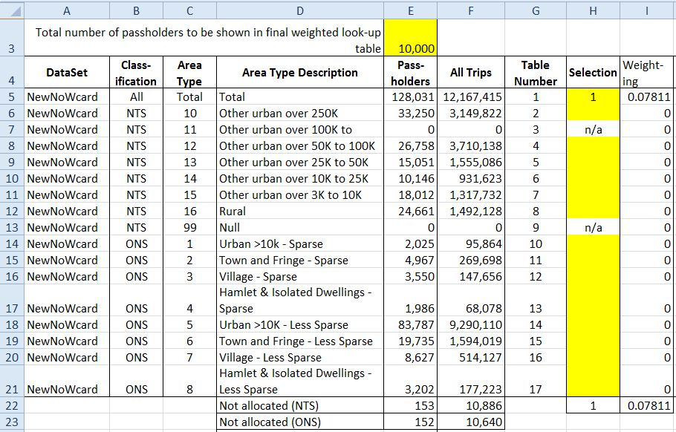
Figure 6.11: User Selection of Area Types

The spreadsheet presents the user with a table that summarises the number of passholders and associated journeys in each of the 17 tables, i.e. by each area type for both NTS and ONS typologies, and the total. The user makes a selection by entering a value in one or more of the yellow highlighted cells, and these values are used as the relative weights with which area types are selected. So specifying a single value calls leads to the look-up results for that particular area type to be reproduced in the results look-up table. Selection of a single area type (or the total) is most transparently carried out by entering a value of “1” (as in Figure 6.3) but input of any non-zero value in a single cell will give identical results. However, if two values are selected, then the “results” look-up table will be weighted by the relative values the user has given to each. So if equal values are given to, say, NTS Area Types 12 and 13, then relative weights of 50:50 will be applied to the relevant look-up tables, giving a results look-up table that is appropriate to a Travel Concession Authority area that is an equal mixture of area types 12 and 13.

There are no arbitrary limits on the values that might be used for selecting area types, and these could be quite large, e.g. the population in each area type for a given TCA (which would lead to a look-up table in which the tables from individual area types are weighted in proportion to the population). To avoid the scale of numbers in the results look-up table becoming too large, the user can specify the total number of passholders that should be represented in the results look-up table; the weighted combinations are then normalised to represent this number of passholders. This value has been preset in cell E3 to 10,000, so if not changed by the user, then irrespective of how look-up tables by individual area types have been combined, the result will always be in terms of the frequency distributions associated with 10,000 passholders.

DfT may use this calculation process as it sees fit, and at its own risk, but should these elements of the spreadsheet be released into the public domain, then Minnerva’s contribution to developing the method and software should be acknowledged.

Indicative Results from New Look up Tables

Testing the implications of new Look-up Tables

A change in the look-up table incorporated into DfT’s Reimbursement Calculator is highly likely to impact on estimated discount factors, and hence average fare estimates and reimbursement. An initial assessment of the impact on discount factors has been made using the same calculation method as incorporated into the DfT 2012-13 Reimbursement Calculator, but with an alternative structure better suited to scenario tests. The alternative structure is such that it produces identical results to those produced by the Calculator when identical inputs are provided, if the initial NoWcard look-up table is selected; but it is structured to facilitate a choice of alternative look-up tables in order to assess their implications.

The impact of alternative look-up tables on discount factors will depend upon the absolute level of fares and the daily and weekly ticket price ratios of a given operator. There is clearly a great range of price ratio combinations, and the results discussed here show the discount factors that would be calculated for illustrative price ratio combinations based on the following options:
- no day ticket, and then day tickets priced at two and three times the average cash fare per journey; and
- no weekly ticket, and then weekly tickets priced at 10, 20 and 30 times the average cash fare per journey.

In considering the implications of these calculations, it should be remembered that a higher discount factor will lead to a lower overall average fare (the average fare per journey that would paid in the absence of the concession), and hence a lower quantum of reimbursement payment than would otherwise be calculated.

The illustrations below are generally on the basis of an assumed average cash fare of £1.50, and are for 2012-13 in a non-PTE area. With the current calculator, for most price ratios, if the average cash fare increases then the calculated discount factor reduces, but this is not always the case.

Overall Impact of the New NoWcard data on discount factors

Figure 7.1 illustrates the discount factors that would be calculated from the current DfT Calculator in its entirety if the look-up tables from the new NoWcard data were substituted for the existing “Initial” NoWcard look-up table.

Discount factors have been calculated from each of three look-up tables:
- the look up table currently incorporated in the Calculator, based on five weeks of data (February and March 2009) on journeys made by NoWcard passholders resident in four Districts in Lancashire (“Initial NoWcard”);
- the new look-up table derived from the more recent data covering one year from September 2009 through to August 2010, obtained for passholders resident in the initial four Districts of Lancashire, and residents of six Districts in Cumbria, using raw (unweighted) data (“New NoWcard Unweighted”); and
- the more recent NoWcard data but using journey data weighted to allow for unrecorded journey transactions (“New NoWcard Weighted”).

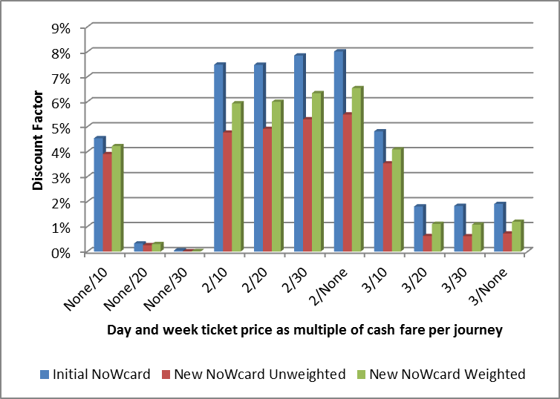
Figure 7.12: Discount Factors by source of Look-up Table

As can be seen, for nearly all price ratios, the new NoWcard look-up tables imply lower discount factors than the initial NoWcard look-up table. The unweighted look-up table from the new NoWcard data gives lower discount factors than the equivalent table based on weighted journey numbers. These relative changes are all consistent with what would be expected from the differences in average journeys per week between the three datasets – it will be recalled from Chapter 5 that the overall journey rate per week for the new NoWcard data was about 4.5% less than for the initial NoWcard data. All other things being equal, a larger journey rate is likely to be associated with a higher discount factor, and vice versa.

Although the overall scale of these discount factors is modest (e.g. less than 5% for a 1:3:10 price ratios), the differences between “new” NoWcard and “old” are substantial as a proportionate of the discount factor, and for that particular price ratio would imply a decrease of 15% in the discount factor if the weighted new-NoWcard look-up table was substituted for the initial NoWcard look-up table. However, the ultimate effect on the average fare paid (e.g. after applying the discount factor to the average cash fare) is relatively slight. In the case of this price ratio, the impact is to reduce the average fare by 0.8%.

Although Figure 7.1 contrasts the discount factors that would be calculated by direct substitution of new NoWcard tables for old, some differences would be expected because of the inclusion of Cumbria Districts in the newer data. However, if Cumbria is excluded from the new NoWcard look-up tables a broadly similar picture emerges to that shown above, with similar relative differences. This implies that, in isolation, the inclusion of the Cumbria Districts has not made a material difference to the overall discount factor estimation, although it has clearly greatly enhanced the range of area types for which meaningful look-up tables can be calculated.

Choice of Weighted or Un-weighted look-up tables

Figure 7.1 shows that un-weighted look-up tables give consistently smaller discount factors than the equivalent weighted tables, as would be expected. As discussed in Chapter 6, weighted tables are based on expansion factors calculated to allow for smartcard transaction failures in which concessionary journeys have not been recorded. Consequently, it would be expected that if weighted values are used, there will be more occasions on which the number of journeys made by a passholder exceed given price ratio thresholds.

Unfortunately, it is not possible to form an a priori judgement about the choice of weighted or un-weighted tables. Equally plausible scenarios of transaction failures suggest that, relative to an unobservable “true” patterns of journey making, un-weighted look-up tables will underestimate discount factors, whereas weighted look-up tables will over-estimate discount factors. Further research on the pattern of transaction failure, and how this might interact with passenger journey frequency distributions, is required before it would be possible to form an objective view as to which approach is likely to lead to least overall bias in discount factors.

In the meantime, an arbitrary but pragmatic way forward is to use look-up tables in which weighted and un-weighted values have been added together, giving the effect of averaging the two. The additional look-up table (“NewNoWcard average”) provided in the Excel file for DfT applies this method, and represents a simple way of putting the idea into practice. As would be expected, resulting discount factors for a given input set of price ratios fall between the higher discount factor derived from the weighted look up table and the lower factor derived from the un-weighted look-up table.

Impact of Area Type

As well as generally enhancing the evidence base from which look-up tables are drawn, one of the main objectives of the current work has been to establish whether discount factors would be more accurate if they reflected the types of area in which passholders live. As discussed in Chapter 5, the propensity to make concessionary journeys varies significantly by area type, and this is reflected in the discount factors that would be calculated if look-up tables are drawn exclusively from residents of individual types of area.

Figure 7.2 shows discount factors derived from the new NoWcard weighted data. Area types are defined on the basis of the Defra/ONS classification.

This shows a wide range of discount factors between area types, and suggests that calculation of discount factors on an area-type basis will generally lead to more appropriate estimates than would be derived if area types are ignored.
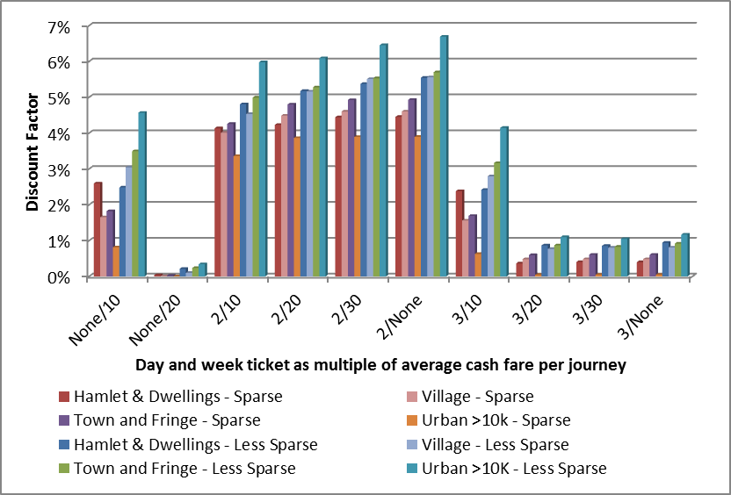
Figure 7.13: Discount Factors by Defra/ONS Area Type

For most price ratios, the discount factor increases as the area type moves towards greater population densities and urbanisation, much as would be expected. The possible exception is the low discount factors in the “Urban > 10K, Sparse” category – although this may simply reflect lack of “intra-urban” services in slightly larger rural settlements. This represents a desirable area for further investigation.

Figure 7.3 shows the discount factors that would be derived if the area type classification is based on the NTS typology. For this chart, data from Area Types 14 (Urban over 10K to 25K) and 15 (urban 3K to 10K) have been combined.
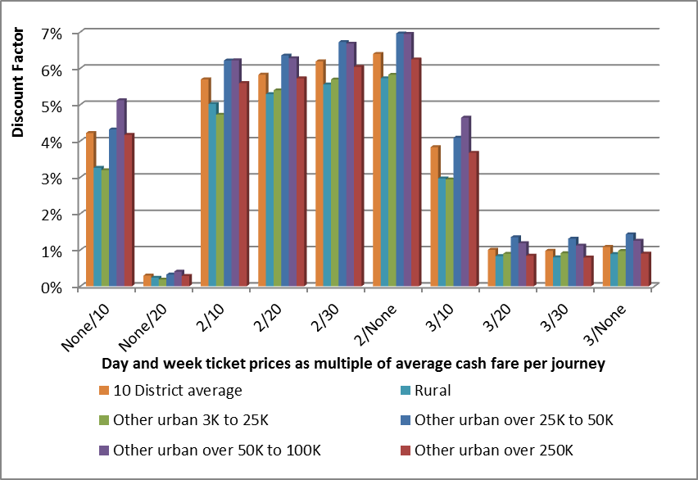
Figure 7.14: Discount Factors by NTS Area Type

For any given set of price ratios, the discount factors associated with each area type vary in similar proportions, with smaller discount factors in rural areas, and larger factors in the most urban areas. For most price ratios, there is very little difference in the discount factors calculated for the “25K to 50K” and “50K to 100K”. However, there is a counter-intuitive fall in the discount factor for the densest urban area, as would be expected from the lower average journey rate the NoWcard data gives for this area type. This is likely to reflect the concerns discussed in previous chapters about the way in which some of the NoWcard area has been classified rather than methodological issues.

Conclusions

Conclusions

The analysis reported here is far from exhaustive and much more could be done to examine the implications of the new NoWcard dataset. The insights available range from better understanding of the likely propensity of concessionary passholders to purchase discount tickets, which was the main purpose of the work, to more general observations of travel behaviour and its potential relationship with a variety of explanatory variables, e.g. car ownership/availability and public transport accessibility/levels of service.

Substantial effort has gone into establishing an extremely large database of information on both passholders and journeys. Considerable time and resource has been devoted to ensuring that as far as is practicable the available data is authentic and accurate.

New look-up tables have been produced which can be directly incorporated by DfT into its Reimbursement Calculator. However, to make full use of the richness of information that is now available, the Calculator should be enhanced to provide the user with a flexible choice of look-up tables. We have provided, in the spreadsheet containing the look-up tables, a method which can be used to allow the user to make a choice of combinations of constituent tables. Although not a deliverable of the project, DfT may wish to make use of the method in disseminating the results, provided appropriate acknowledgement is made of its origins.

The working hypothesis at the outset of the study was that some form of disaggregation by area type would provide the best way for individual Travel Concession Authorities (TCAs) to select look-up tables that were appropriate to their own area type. The results reported here suggest that this would indeed be a desirable way forward, and could meaningfully improve the accuracy with which TCAs calculated average fares for their own areas. However, it remains the case that the results available to date can only be considered to be truly representative of the areas of Lancashire and Cumbria from which the data was drawn.

The inclusion of Cumbria greatly increases the representation of rural areas in the dataset, but the fact is that larger, denser urban areas will not be properly represented in the NoWcard dataset. So, further acquisition of smartcard data from which look-up tables can be constructed is highly desirable if the generality of the discount fare estimation method is to be assured.

A number of practical issues remain to be resolved, and further exploration of area type issues is desirable to ensure that a fully practicable and robust methodology is made available to TCAs. Some questions also remain about the explanation for some aspects of the observed data; pursuing these would almost certainly shed more light on issues such as the choice of area type classification.


MVA Consultancy provides advice on transport, to central, regional and local government, agencies, developers, operators and financiers.
A diverse group of results-oriented people, we are part of a strong team of professionals worldwide. Through client business planning, customer research and strategy development we create solutions that work for real people in the real world.

For more information visit www.mvaconsultancy.com
Email: info@mvaconsultancy.com

Offices also in
Bangkok, Beijing, Hong Kong, Shenzhen and Singapore

Abu Dhabi
AS Business Centre, Suite 201, Al Ain Road, Umm al Nar, P.O. Box 129865, Abu Dhabi, UAE
T: +971 2 510 2402 F: +971 2 510 2403

Birmingham
Second Floor, 37a Waterloo Street
Birmingham B2 5TJ United Kingdom
T: +44 (0)121 233 7680 F: +44 (0)121 233 7681

Dublin
First Floor, 12/13 Exchange Place
Custom House Docks, IFSC, Dublin 1, Ireland
T: +353 (0)1 542 6000 F: +353 (0)1 542 6001

Edinburgh
Second Floor, Prospect House, 5 Thistle Street,
Edinburgh EH2 1DF United Kingdom
T: +44 (0)131 220 6966

Glasgow
Seventh Floor, 78 St Vincent Street
Glasgow G2 5UB United Kingdom
T: +44 (0)141 225 4400 F: +44 (0)141 225 4401

London
Second Floor, 17 Hanover Square
London W1S 1HU United Kingdom
T: +44 (0)20 7529 6500 F: +44 (0)20 7529 6556

Lyon
11, rue de la République, 69001 Lyon, France
T: +33 (0)4 72 10 29 29 F: +33 (0)4 72 10 29 28

Manchester
25th Floor, City Tower, Piccadilly Plaza
Manchester M1 4BT United Kingdom
T: +44 (0)161 236 0282 F: +44 (0)161 236 0095

Marseille
76, rue de la République, 13002 Marseille, France
T: +33 (0)4 91 37 35 15 F: +33 (0)4 91 91 90 14

Paris
12-14, rue Jules César, 75012 Paris, France
T: +33 (0)1 53 17 36 00 F: +33 (0)1 53 17 36 01

Woking
Dukes Court, Duke Street, Woking
Surrey GU21 5BH United Kingdom
T: +44 (0)1483 728051 F: +44 (0)1483 755207

As in the 2012-13 Guidance published by DfT in Nov 2011 and incorporated in the spreadsheet named “111129 Reimbursement Guidance 2012-13 v3.1 - FINAL.xls”
The look-up table itself was constructed by Andrew Last of Minnerva Ltd in association with MVA Consultancy, using data provided by the NoWcard consortium. The work is documented in Chapter 4 of “Concessionary Travel – The Research Papers”, Institute for Transport Studies, University of Leeds, November 2010
Between 09:30 and 23:00 on weekdays, and at all times on Saturdays, Sundays, and Bank Holidays.
Lancashire operates on a four-weekly, 13 periods per annum, reporting basis, whilst Cumbria reports on a month by month basis.
This reflects the same issues arising from exclusion of non-resident journeys from the look-up table datasets discussed in Chapter 2. In principle, the propensity of non-residents to buy discount tickets may differ from that of residents, and this could mean that the look-up table adopted by a TCA to correspond with its own area type will not be wholly appropriate for a proportion of the journeys for which operators seek reimbursement. However, subject to any data that may be available, the overall proportion of journeys made by non-residents is probably small, although will be more significant in a number of “honey-pot” areas.
http://www.defra.gov.uk/statistics/rural/what-is-rural
It is worth noting that data from the 2011 Census will not be released at this OA level, rendering them obsolete with reference to up-to-date datasets on population characteristics etc.
Whilst National Travel Survey (NTS) data for self-contained areas between 25,000 and 250,000 population are reported as a whole, this data can be further disaggregated by the DfT, as in Table 5.
The Department for Transport’s Concessionary Travel Reimbursement Guidance for 2012-13 recognises the increasingly wider availability of smartcard data in a sufficiently comprehensive form to be directly drawn upon by individual TCAs. The Guidance suggests that the NoWcard data in the model can be replaced with local smartcard data or smartcard data from another area which can be demonstrated to be representative.
Calculated from a journey total of 11.753 million journeys made during the year, by a total of 176, 868 passholders with a pass first issued before 1st September 2009, and assuming 52 weeks per year.
It should be emphasised that it is not clear whether look-up tables from weighted or un-weighted journey data for will provide the least biased estimate of discount factors. It is highly likely that higher discount factors will be derived from weighted look up tables, and lower discount factors from un-weighted look-up tables, but it is not known where the true figure lies between these two extremes, because the pattern of unobserved “manual” transactions is unknown.
It should be recalled that these passholder estimates are based on card issuing records and may include passholders who are deceased or who have moved away.
For convenience, the 364 days were regarded as 52 consecutive and complete 7-day weeks.
In practice, the number of passholders not allocated for this reason were fewer than 100.
Version 3.1 dated 29th November 2011

