passenger transport executive group

File Note: Principles and application of DfT “Discount Factor Method”

April 2014

Introduction
The “Discount Factor method” was devised in order to assist Travel Concession Authorities estimate the potential use of day and week tickets by passholders in the counterfactual. It was conceived as an alternative to the “basket of fares” method, with less reliance on data which was likely to be conditioned by assumptions.
The basket of fares method, which the Guidance continues to provide as an option, is simply a weighted average calculation, in which estimates have to be made of the number of journeys that would be made in the counterfactual using each of the three generic ticket types (cash, day and week tickets), alongside estimates of the average fare per journey when made by each ticket type. There are bus industry “rules of thumb” about the relative usage of day and weekly tickets, but these are generally assumptions and may not be sensitive, as they should be, to the relative prices of each ticket type.
Overview of Discount Factor Method
The “discount factor method” populates the relative usage and price per journey of the basket of fares calculation with values drawn from a look-up table, based on observed concessionary journeys collected through smartcard data. The look-up table summarises the frequency with which passholders make different numbers of concessionary journeys on each day and each week of a reference period. However, it is necessary to allow for the fact that observed concessionary journeys are likely to be more frequent than those that would be observed in the counter-factual, because of generation. An overview of the process is shown in Figure 1.

Figure 1 Overview of DfT Average Fare Methodology
The look-up table included in the DfT Calculator was built from 5 weeks of data on concessionary journeys made in 4 Lancashire districts in 2009. It summarises the frequency of concessionary trip making by about 90,000 passholders (including those making no journeys), who in total make about 590,000 journeys in the 5 week period.
The Discount Factor method draws on the look-up table within the following process:
- the starting point is data from the operators on commercial ticket sales (i.e. the number of tickets sold) and the associated revenues for each of three generic ticket types. The average fare per journey for cash fares, and the average price per ticket for day and weekly tickets can then be calculated.
- These relative prices are expressed in terms of price ratios, which represent the price of daily and weekly tickets expressed as a multiple of the average cash fare per journey. These are taken to represent the number of journeys that a passenger would need to make in a day or week for it to be cheaper to buy the day or weekly ticket rather than pay cash.
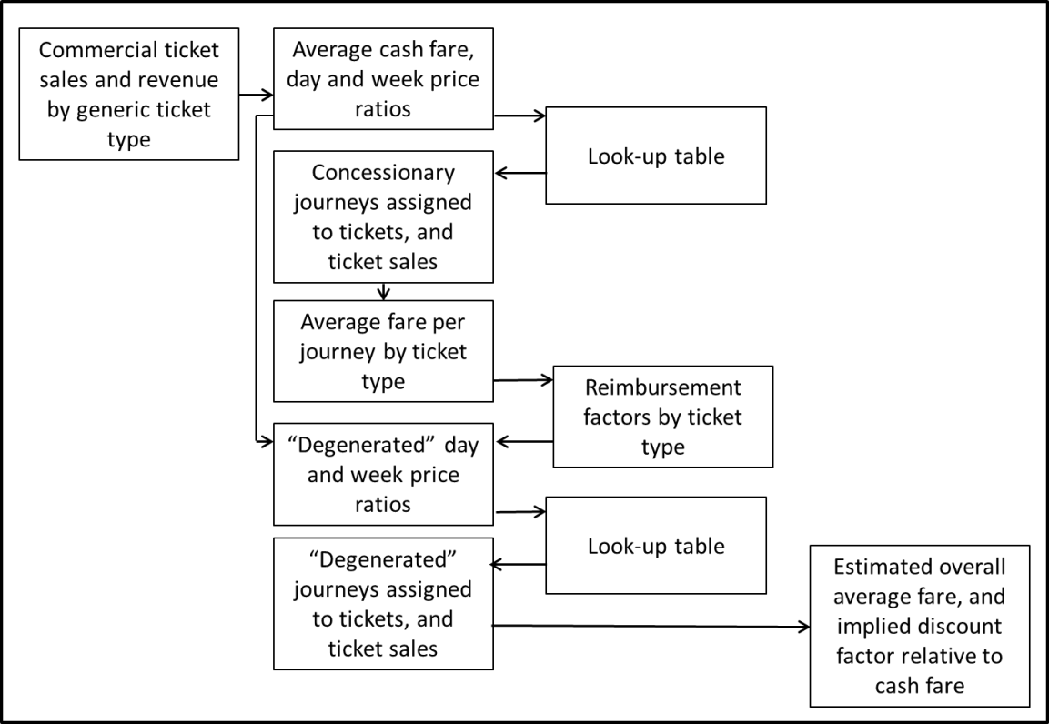
- The look-up table represents an assignment of the total number of journeys observed in the NoWcard dataset to different combinations of day and week ticket price ratios. For each set of price ratios, the look-up table provides:
  - a count of the number of “passholder weeks” in which the observed concessionary journeys were equal to or greater than the week ticket price ratio. These are regarded as equivalent to the number of weekly ticket sales that would have been made in the counter-factual;
  - the sum of the number of these “weekly ticket” journeys;
  - for those journeys not assigned to weekly tickets, the number of “passholder days” in which the number of journeys made was equal to or greater than the day ticket price ratio;
  - the sum of the number of these “day ticket” journeys
  - the sum of those journeys not assigned to day or week tickets.
In the first part of the procedure, these are used to establish the average fare per journey for each of the three ticket types.
- The average fares per journey are then input into calculations of reimbursement factors for each ticket type. These are intended to reflect the extent to which the observed concessionary journeys have been generated by the free concession. It should be noted that these are quite independent of the “main” reimbursement factor calculation within the DfT spreadsheet, although they draw (in principle) on identical parameters.
- The price ratios are adjusted so that the look-up table can be referenced as if it contained only non-generated journey data. This process, known as “degeneration” represents the least-intuitive aspect of the discount factor method and is discussed in more detail below.
- The look-up table is examined again, but this time with the degenerated price ratios. The result is a second assignment of journeys, and counts of ticket sales, to the three ticket types, but now supposedly fully reflecting the counter-factual situation.
- The output from this second reference to the look-up tables is used to calculate the “final” discount factor, which can then be fed back to the other parts of the Calculator spreadsheet for use in estimating the revenue forgone.
Of these steps, there are concerns about the way in which both degeneration, and the calculation of the final discount factor, are handled within the current Calculator. These are now discussed in more detail.
Degeneration
The look-up table reflects the observed frequency with which concessionary journeys are made at the (free) concessionary fare. Journeys will therefore be more frequent than if a fare had to be paid, and, consequently, a method is needed to “degenerate” the observed journey frequency distributions, in other words take out the journeys generated by the concession. The method adopted is to change the price ratios used to look-up the journey and ticket volumes.
To illustrate the concept, assume that the Reimbursement Factor is 50%. Then for every four observed concessionary journeys, it is assumed that only two would be made in the counterfactual. Suppose that the day ticket price ratio is 2. In the counter-factual, we would want to identify the number of passholder days in which 2 or more non-generated journeys were made. But the look-up table includes generated journeys. So in order to identify the number of passholder-days in which 2 or more non-generated journeys are made, we need to look up the number of passholder days in which 4 (i.e. 2 divided by the Reimbursement Factor) or more concessionary (i.e. both generated and non-generated) journeys were made.
In effect, degeneration changes the “fare” axis of a trip frequency distribution. The distribution of journey frequencies is illustrated in Figure 2; it shows the percentage of total journeys made (the vertical axis), plotted against the number of journeys made per day.
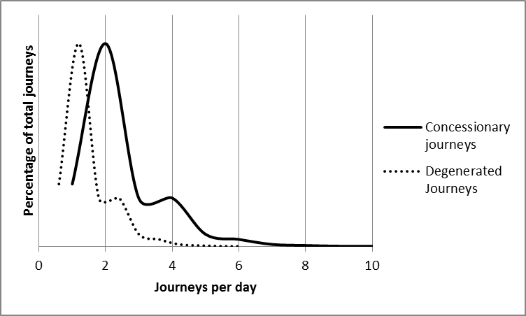

Figure 2: Frequency distribution of journeys made per day
The solid line represents the observed distribution of concessionary journeys; most journeys are made on days in which two journeys are made. The way that degeneration is applied in the DfT model is to assume that the overall shape of the frequency distribution remains the same, but that in effect the horizontal scale is shifted to allow for journeys generated by the concession. The net effect is thus to considerably reduce the number of days on which the day ticket price ratio is equalled or exceeded, and likewise for weekly tickets.
Implementation of degeneration in the DfT Calculator Spreadsheet
The discussion above sets out a plausible rationale for the discount factor method, although inevitably it relies upon various assumptions, particularly with regard to the uniform scale of generation irrespective of the number of trips frequency by individual passholders. However, there are concerns that the detailed implementation of these concepts within the DfT Calculator is not correct.
First, the calculation of “Degenerated” price ratios – the way in which Reimbursement Factors are applied to the input Price Ratios - appears to be in error. This aspect of the method is set out in Block (4) of the DfT Calculator “AF Workings” worksheet, labelled as “Degenerate price ratio”. Cells Q8 and Q9 contain Reimbursement Factors that are calculated from the average price per journey for daily and weekly tickets derived from the look-up table from the input ticket prices.
In our view, the “degenerated” price ratio should be calculated by dividing the input price ratio by the Reimbursement Factor. This would imply that, as in the case of the simple example above, an input price ratio of 2 would be transformed to a price ratio of 2/0.5 = 4 . Instead, the calculation in cells R8 and R9 multiplies the input price ratio by (1+RF), giving an output price ratio of 3. We are unclear what the rationale is for this expression, but it does not seem that it would correctly derive the counter-factual price ratio equivalent to observed concessionary journeys. It would almost inevitably underestimate the degenerated price ratios, and consequently lead to over-estimates of discount factors.
Second , it is not clear how the principle of looking-up usage of day and weekly tickets using degenerated price ratios should be applied to cash journeys. The current Calculator applies a Reimbursement Factor to cash journeys (in this instance, correctly) not “re-assigned” to day and weekly tickets with the degenerated price ratios. But this does not seem to properly reflect the use of the look-up table when used in “degeneration” mode. In our view, the journeys assigned to day and week tickets using the degenerated price ratios should be regarded as assignments of degenerated journeys as a whole. For consistency, all the journeys not assigned to day or week tickets should also be “degenerated”. This could be through applying a single Reimbursement Factor to the total number of journeys in the look-up table and then subtracting those assigned to day and weekly tickets with the degenerated look-up table, or applying the Reimbursement Factor to the journeys not assigned to day and weekly tickets with the degenerated look up table. The DfT arithmetic mixes journeys numbers from both the initial and degenerated look-up table processes, which conceptually does not seem to be correct. Using either of the more consistent alternatives is likely to lead to higher discount factors.

Final Discount Factor Calculation.
The “final” discount factor is calculated in cell AG18 of the DfT spreadsheet by reference to the “degenerated” price ratios, the assigned number of ticket sales by each ticket type and the associated volume of total degenerated journeys. However, in our view this is misconceived, since the degenerated price ratios are only a mechanism for inferring the price thresholds that should apply to the observed concessionary journeys that would be equivalent to the counter-factual journey volumes. It is unfortunate that the DfT spreadsheet calculates the Discount Factor directly rather than through the intermediate step of calculating the average fare forgone, because this obscures the different ways in which discount factors are calculated within the spreadsheet.
This is best demonstrated by comparing the discount factor calculations used at different points in the DfT Average Fare Workings worksheet. For these illustrations, the 2013-14 version of the DfT Calculator spreadsheet has been used, with a “PTE” area type specified, and with the reimbursement year set to 2013-14. The “AF model” worksheet has been populated with input ticket prices of £2.00 for the average cash fare, £4.00 for the average daily ticket price and £20.00 for the average weekly ticket price. This worksheet reports that the discount factor before degeneration is 19.09%, the Final discount factor is 7.48%, giving an Average Fare Forgone £1.85. Note that this is calculated (within this worksheet) as the average cash fare * (1- Discount Factor) i.e. £2.00 * (1-0.0748), which is indeed £1.85.
Worksheet AF Workings contains the detailed calculations. Cells K6:N18 gives the results of the initial reference to the look-up table, prior to “degeneration”, and reports identical values of the pre-degeneration discount factor, calculated in different ways. Picking apart these calculations, the average fare forgone (which is the key intermediate result) is calculated in cell L18 from the weighted sum of the journeys made by ticket type, and the average price per journey (which in combination gives total revenue). Divided by the sum of all journeys, to give the average price per journey. Cell M19 gets to the same result, by using the weighted sum of the price per ticket, and the number of tickets sold.
Cells AD5:AG8 gives the results from the post-degeneration reference to the look-up table, which has used “degenerated” price ratios. The number of tickets sold and journeys made reported here therefore represent the use that would be made of cash, daily and weekly tickets in the counter-factual. But the discount factor calculated in cell AG18 is not consistent with the journeys that are reported from the look-up table. In contrast to the discount factor calculations prior to degeneration, cell AG18 uses the “degenerated” price ratios. This seems misconceived, since the degenerated price-ratios are simply a device through which the pre-degeneration journey numbers represented in the look-up table can be accessed as if they reflected the counter-factual situation. This is most easily demonstrated through the implied revenue totals:
- The product of the number of tickets sold and the actual prices charged is £902,857, which gives an average revenue per journey of £1.65
- The product of the number of journeys and the average price per journey made on each ticket type is identical;
- The product of the number of tickets sold and the degenerated price ratios (as per DfT calculation), and the cash fare price, is £1,014,616 which gives an average fare per journey of £1.85, as per the Calculator.
In our view, if the Discount Factor method is taken at face value as a reasonable way of inferring the number of tickets sold and journeys made in the counter-factual, then the average fare forgone should be consistent with discount factors derived from the simulated counter-factual ticket sales and journeys assigned to each ticket type, and not the degenerated price ratios.
The overall impact of these issues is to imply that the “Final Discount Factor” estimated by the DfT Calculator significantly overstates the resulting average fare forgone. This is confirmed when the output from the DfT Discount Factor method is compared to the results of “Basket of Fares” type calculations using a combination of data from operators and PTE continuous surveys. The latter may have the potential to provide comprehensive data on passenger journeys, by all ticket types, as well as on-bus revenues. Operators should be able to provide good data on all passenger revenues, including those from both on-bus and off-bus sources. Where off-bus revenue is significant, operators are likely to be best placed to estimate the average fare per journey for commercial passengers, which is a required input to additional capacity cost calculations. By combining this information with PTE survey data, it is possible to populate a “basket of fares” calculation of the average fare forgone, which can be contrasted with that produced by the discount factor method.
Table 1 shows data from four example operators from two different PTEs for which it has been possible to assemble the requisite data. In each case they are the largest operators within their respective areas.

Year | 2009/10 | 2009/10 | 2012/13 | 2012/13
PTE | PTE A |  | PTE B
Operator | Operator A1 | Operator A2 | Operator B1 | Operator B2
Average cash fare per journey | £1.475 | £1.856 | £1.790 | £1.691
Average day ticket price | £3.621 | £4.087 | £4.397 | £3.674
Average week ticket price | £10.462 | £17.278 | £15.209 | £12.060
Estimates of Average fare Forgone:
from DfT Discount Method | £1.331 | £1.726 | £1.658 | £1.516
Implied discount factor relative to average cash fare | 9.8% | 7.0% | 7.4% | 10.3%
Corrected DfT Discount Factor method | £1.132 | £1.582 | £1.498 | £1.264
Implied discount factor relative to average cash fare | 23.3% | 14.8% | 16.3% | 25.3%
Basket of Fares Calculation | £0.970 | £1.350 | £1.409 | £1.284
Implied discount factor relative to average cash fare | 34.2% | 27.2% | 21.3% | 24.1%
Table 1 Comparisons of Discount Factor Calculations – Four Example Operators

In all instances, the discount factor estimated by the DfT Calculator Discount Factor method is less than half the value that would be calculated if the methodology was implemented more correctly. The corrected discount factors are in turn less than the discount factors that would be calculated from basket of fares calculations in three out of four cases.

In practice there is a finite range of day ticket price ratios from 1 to 10 (including the possibility of there being no day ticket, and 1 to 40 for weekly tickets (including the possibility of there being no weekly ticket)
Ironically, although we doubt that the intention here is conceptually sound, the application of the Reimbursement Factor to journey numbers in this instance is correct, with the journey numbers divided by the Reimbursement Factor. This contrast to the treatment of day and weekly ticket price ratios, which are multiplied by (1+RF).

