|  |  |
| --- | --- |
| ***passenger transport executive group***  **File Note: Differences in the journey length distributions of users of different ticket types**  *April 2014* |  |

Amongst other complications in the measurement of average fares, there are a number of alternative ways in which the average cash fare could be calculated. This is because the journey length distribution is likely to vary between passenger types, and may also depend upon the commercial strategy of operators. Some PTEs collect continuous survey data from passengers in sufficient detail to allow this to be demonstrated.

This is illustrated in Figure 1, which shows the journey length distributions of cash and concessionary passenger types in one PTE, for two operators which carry passengers with contrasting journey length distributions.

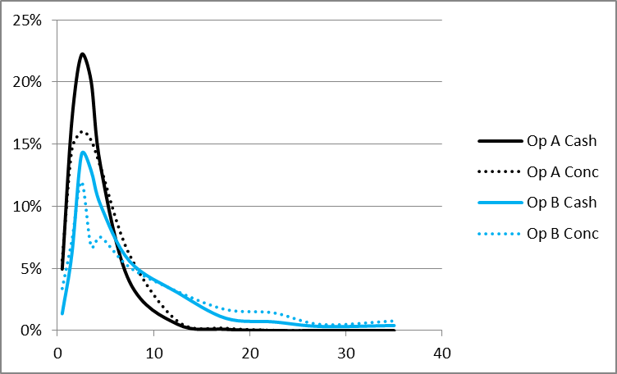

**Figure 1 Journey length distributions of cash and concessionary passenger**

In this particular PTE, concessionary journeys are longer on average than journeys made by commercial passengers using cash fares. Operator A runs predominantly urban services, while Operator B has many more inter-urban services. For both operators, the proportion of shorter journeys is much greater for passengers paying cash fares than it is for concessionary journeys. This is reflected in the overall average journey lengths which are 18% and 22% greater for concessionary passengers than for cash passengers using Operator A and B’s services, respectively. However, such differences are dependent upon other characteristics. For the same PTE and a third, equally significant operator, there is a very small variation (3.3%) in the average journey lengths of concessionary and cash passengers. And in at least one other PTE, concessionary journeys are on average slightly shorter than non-concessionary adult journeys, including cash payers.

However, the consequence is that there may be big differences between the “average cash fare” calculated from actual commercial adult cash-paying passengers, and the equivalent cash fare that would be paid by concessionary passengers. A further complication is that operators’ ticket pricing strategies may also influence the journey length distributions of users of cash fares compared to users of other ticket types. PTEs are often able to calculate the cash fares that various groups of passengers would have paid because they record where passengers board and alight, and can relate these to operator cash fare scales. In a second PTE area, ticket prices are such as to encourage commercial passengers making longer distance journeys to buy daily and weekly tickets rather than use cash fares. This is shown through the average cash fare that would have been paid for the journeys made using each of the main ticket types, as set out in Table 2.



**Table 2 Example average equivalent fares for different commercial products**

Because the cash fare will be strongly correlated with the average journey length, users of day tickets can be seen to travel significantly longer distances per journey compared to users of cash tickets. Despite this, the average cost per journey (when the price of the tickets is divided by the number of journeys made with each ticket purchased) is significantly less than for users of cash tickets. The journeys made by users of weekly tickets are at an even greater discount to the average cash fare, but on average are between the two with regard to journey length.