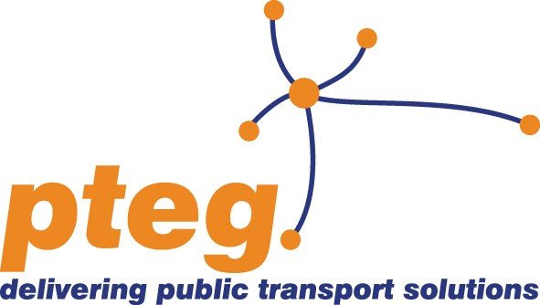 | pteg - is the Passenger Transport Executive Group – which brings together and promotes the interests of the six Passenger Transport Executives (PTEs) in England.

pteg response to the consultation on the 5th report on Economic, Social and Territorial Cohesion

pteg, as the group which represents the six English Passenger Transport Executives in England:

- Welcomes the recognition that there should be cohesion policy for all areas of the EU.
- Emphasises that the recognition of the importance of cohesion policy for all regions should not be followed by a restriction of activities in some areas.
City regions need high quality public transport networks to ensure that people have access to the jobs, services and attractions that city centres provide. City region economies also need good connectivity to and from their urban centres and beyond.
It may be that an area with significant growth potential will still need to invest in transport infrastructure for instance, and should be enabled to do this where there is a sound economic and environmental basis.
- Welcomes the strong emphasis on the importance of urban areas - ensuring a strong urban dimension in cohesion policy will help to deliver the aims of the Europe2020 strategy.
The six largest city regions outside London are home to eleven million people. They contain core cities that are major drivers of the UK economy, like Leeds, Manchester, Liverpool, Newcastle, Sheffield and Birmingham. In Europe, cities now account for 75% of our population, 80% of energy use and 85% of Europe's GDP.
The city regions are also home to some of the biggest concentrations of deprivation and unemployment in the country. People on a low income are also disproportionately reliant on buses. Investment in transport can help tackle inequality by connecting people to jobs, and ensuring that low income families can get access to services and opportunities.
- Welcomes the recognition of the importance of a well developed and clean transport infrastructure and emphasises the need for this to translate into potential funding measures in all regions.
Modern and efficient transport networks are crucial to ensuring that city regions can thrive in a way that is smart and green.
In urban areas the air we breathe can still be well below the standards set for air pollution. Transport policy needs to play its part in meeting these challenges through strategies designed to cut carbon and reduce pollution.
- Emphasises the importance of local development approaches and integrated planning.
The importance of local flexibility in the development of integrated plans must not be lost or overlooked. The principle of subsidiarity will be essential to the success of cohesion policy.
The role of functional economic areas must not be overlooked in cohesion policy. These areas must have the flexibility to define their own programmes within the broad confines of the EU2020 strategy, engaging communities and civil society in the definition and delivery of projects.
- Welcomes a continuing emphasis on financial engineering as a means to fund large scale infrastructure but recognising that this cannot entirely replace grant funding.
The experience of the European Investment Bank in financing large scale transport infrastructure in the EU will be vital to ensuring the expansion and better use of financial engineering instruments to deliver the aims of Europe2020.
There will remain a need for grant funding too however. It will be important to ensure that there is flexibility to fund transport infrastructure through grant or financial engineering (or combinations of both) as appropriate.

- Recognises the need to re-evaluate the indicators used – workplace GDP alone is too blunt an instrument and does not give an accurate picture of the true economic situation in terms of opportunities and weaknesses which cohesion policy should address.
There should be a focus on indicators which reflect where people live, where people work and how they are able to travel between the two. The ability or otherwise to travel to employment opportunities can have a huge impact on urban communities.
- Welcomes the proposed shift to a focus on results. A shift in focus away from compliance with administrative rules and towards outcomes should help to deliver meaningful programmes of development which better benefit communities.
Investment in transport infrastructure will help to deliver wider economic benefits which are better reflected by a focus on results. Such a focus also provides a more realistic assessment of the true impact of investments.

